Data Visualization Storyline

A PROJECT REPORT

Submitted by

NAME OF THE CANDIDATE(S)

Ronak Lodhi (24BCS10431)

Archit Sharma (24BCS12916)

Jatin Kumar (24BCS10850)

In partial fulfillment for the award of the degree of

Bachelors in Engineering (B.E)
IN
Computer Science Engineering(C.S.E)



Chandigarh University
April, 2026



BONAFIDE CERTIFICATE

Certified that this project report “………. Data Visualization Storyline…………….” is the bonafide work of “………….. Ronak Lodhi (24BCS10431), Archit Sharma (24BCS12916), Jatin Kumar (24BCS10850) .…………”who carried out the project work under my/our supervision.

Signature Signature

(HOD) (Supervisor)
B.E-CSE

Submitted for the Project viva voice examination held on:

INTERNAL EXAMINER EXTERNAL EXAMINER

Contents
Data Visualization Storyline 1
A PROJECT REPORT 1
Submitted by 1
NAME OF THE CANDIDATE(S) 1
In partial fulfillment for the award of the degree of 1
Bachelors in Engineering (B.E.) 1
IN 1
Computer Science Engineering (C.S.E.) 1
Chandigarh University 1
BONAFIDE CERTIFICATE 1
Certified that this project report "Data Visualization Storyline" is the bonafide work of "Ronak Lodhi (24BCS10431), Archit Sharma (24BCS12916), Jatin Kumar (24BCS10850)" who carried out the project work under my/our supervision. 1
Signature of the HoD 1
SIGNATURE 1
Name of the Head of the Department 1
HEAD OF THE DEPARTMENT 1
Department 1
INTERNAL EXAMINER 2
Signature of the Supervisor 2
SIGNATURE 2
Name 2
SUPERVISOR 2
Academic Designation 2
Department 2
EXTERNAL EXAMINER 2
ACKNOWLEDGEMENT: 12
ABSTRACT: 13
Chapter 1: 14
INTRODUCTION: 14
Chapter 2: 15
DATA ORIGIN - KAGGLE SUPERMARKET SALES DATASET: 15
Source Platform: Kaggle: 15
Dataset Description and Schema: 16
Column 16
Description 16
Dataset Characteristics and Suitability: 16
Link: https://www.kaggle.com/code/chrisstodd/supermarket-sales-analysis 16
Chapter 3: 16
LITERATURE REVIEW: 16
Tufte's Data-Ink Ratio (1983) 16
Narrative-Driven Visualization: Knaflic (2015) 17
Python Analytics Ecosystem and Web Delivery 17
Automated Storytelling and NLG 17
Chapter 4: 17
EXISTINGWORK 17
Microsoft Excel Dashboards 18
Tableau and Microsoft Power BI 18
Jupyter Notebooks 18
Auto-EDA Tools: Pandas Profiling and Sweetviz 18
Comparative Gap Analysis and Project Positioning 18
Chapter 5: 19
PROPOSED SYSTEM: 19
Core Design Principles 19
System Features 19
Technology Stack 20
Component 20
Description 20
Chapter 6: 20
METHODOLOGY (Stages 1-3) 20
Stage 1: Data Collection and Ingestion (P1 - ingestion.py) 20
Stage 2: Data Cleaning and Preprocessing (P2 - cleaning.py) 20
Stage 3: Statistical Analysis (P3 - analysis.py) 21
METHODOLOGY (Stages 4-6) 21
Stage 4: Data Visualization (P4 - visualization.py) 21
Stage 5: Narrative Generation (P5 - narrative.py) 21
Stage 6: Report Compilation (P6 - report_builder.py) 21
Chapter 7: 22
DATA FLOW DIAGRAM (DFD) 22
Level 0 DFD - Context Diagram 22
Level 1 DFD - Internal Pipeline Processes 22
Process 22
Module 22
Input 22
Output 22
Architecture Summary 22
Chapter 8: 23
ROLES AND RESPONSIBILITIES 23
Ronak Lodhi (24BCS10301) - Data Engineering Lead 23
Archit Sharma (24BCS10412) - Analysis and Chart Strategy Lead 23
Jatin Kumar (24BCS10523) - Visualization, Web Interface, and Report Lead 24
Chapter 9: 24
PYTHON LIBRARIES & TECHNOLOGY STACK 24
Library 24
Version 24
Purpose 24
Why Python? 25
CHART SELECTION GUIDE 25
Data Type 25
Chart Type 25
Use Case 25
Automated Chart Recommendation Logic 26
DATA CLEANING - DEEP DIVE 26
Missing Value Treatment 26
Duplicate Record Removal 26
Data Type Standardization 26
Outlier Detection and Handling 27
EXPLORATORY DATA ANALYSIS (EDA) 27
Univariate Analysis 27
Bivariate Analysis 27
Multivariate Analysis 27
Time Series Analysis 27
VISUALIZATION NARRATIVE FRAMEWORK 28
The SCQA Structure 28
Automatic Statistic Injection 28
Audience Adaptation 28
Narrative Quality Checks 28
SYSTEM ARCHITECTURE 28
Module 1 - Data Ingestion Layer 29
Module 2 - Data Cleaning Layer 29
Module 3 - Analysis Engine 29
Module 4 - Visualization Module 29
Module 5 - Narrative Generator 29
Module 6 - Report Builder 29
CASE STUDY - RETAIL SALES DATASET 30
Chapter 1: The Data at a Glance 30
Chapter 2: Which Categories Drive Revenue? 30
Chapter 3: Regional Performance Patterns 30
Chapter 4: Customer Segment Insights 30
Chapter 10: 31
TESTING AND VALIDATION 31
Unit Testing 31
Integration Testing 31
Output Validation 31
Performance Benchmarks 31
Chapter 11: 32
FUTURE WORK & EXTENSIONS 32
Machine Learning-Based Predictive Narratives 32
Real-Time Data Feeds 32
Interactive Web Dashboard 32
Natural Language Querying 32
Multi-Language Narrative Support 32
STATISTICAL CONCEPTS USED 33
Measures of Central Tendency 33
Measures of Dispersion 33
Correlation Analysis 33
Hypothesis Testing 33
Regression Analysis 33
DATA ETHICS AND PRIVACY 34
Data Minimization 34
Anonymization and Pseudonymization 34
Algorithmic Fairness 34
Audit Trails and Accountability 34
Transparency in Visualizations 35
COLOUR THEORY IN DATA VISUALIZATION 35
Sequential, Diverging, and Categorical Palettes 35
Colour Accessibility 35
Semantic Colour Conventions 35
Background and Contrast Ratios 36
VERSION CONTROL AND REPRODUCIBILITY 36
Git Repository Structure 36
Dependency Pinning 36
Random Seed Management 36
Dataset Fingerprinting 36
Report Versioning 37
PERFORMANCE OPTIMIZATION 37
Chunked Reading for Large Files 37
Vectorized Operations 37
Lazy Evaluation with Dask 37
Chart Rendering Optimization 37
Caching Analysis Results 38
COMPARATIVE ANALYSIS - VISUALIZATION TOOLS 38
Criteria 38
This Project 38
Tableau 38
Power BI 38
Excel 38
Jupyter 38
ERROR HANDLING AND LOGGING 39
Error Taxonomy 39
Structured Logging 39
Graceful Degradation 39
Input Validation Schema 39
CI/CD PIPELINE AND DEPLOYMENT 39
Continuous Integration Workflow 40
Test Coverage Requirements 40
Continuous Deployment 40
Environment Configuration 40
API DESIGN AND INTEGRATION 40
API Endpoint Reference 41
Endpoint 41
Method 41
Description 41
Authentication 41
Rate Limiting and Quotas 41
DATABASE SCHEMA AND PERSISTENCE 41
Core Tables 41
Audit Log Table 42
Indexing Strategy 42
Data Retention Policy 42
SECURITY ARCHITECTURE 42
Network Security 42
Application Security 42
Data Encryption 43
Penetration Testing 43
USER RESEARCH AND FEEDBACK 43
Initial Requirements Gathering 43
Key User Insights 43
Usability Testing 43
Post-Deployment Feedback 44
INDUSTRY APPLICATIONS 44
Retail and E-Commerce 44
Healthcare and Clinical Research 44
Financial Services 44
Education 45
Manufacturing and Supply Chain 45
LIMITATIONS AND CONSTRAINTS 45
Data Volume Limits 45
Narrative Quality Boundaries 45
Causal Inference 46
Unstructured Data 46
Real-Time Streaming 46
AGILE DEVELOPMENT PROCESS 46
Sprint Structure 46
Sprint Highlights 46
Backlog Management 47
Team Collaboration Tools 47
MACHINE LEARNING INTEGRATION 47
Anomaly Detection 47
Clustering Analysis 47
Demand Forecasting 48
Feature Importance 48
GRAPH THEORY APPLICATIONS 48
Network Construction 48
Centrality Analysis 48
Community Detection 49
Network Visualization 49
DOCUMENTATION STRATEGY 49
Code Documentation 49
User Documentation 49
Developer Documentation 49
Decision Records 50
SCALABILITY ANALYSIS 50
Horizontal Scaling 50
Database Scaling 50
Storage Scaling 50
Analysis Job Scaling 51
TEAM REFLECTIONS AND LEARNING OUTCOMES 51
Ronak Lodhi - Data Engineering Perspective 51
Archit Sharma - Data Analysis Perspective 51
Jatin Kumar - Visualization and Communication Perspective 51
Collective Team Reflection 52
APPENDIX B - CONFIGURATION SCHEMA 52
Parameter 52
Type 52
Default 52
Description 52
APPENDIX C - SAMPLE GENERATED NARRATIVE 53
Analyst Mode Narrative 53
Manager Mode Narrative 54
APPENDIX D - PROJECT TIMELINE 54
Sprint 54
Duration 54
Planned Work 54
Completed/Notes 54
APPENDIX E - TEST COVERAGE REPORT 55
Module 55
Coverage 55
Notes 55
Overall 55
91% 55
APPENDIX F - PERFORMANCE BENCHMARK RESULTS 56
Dataset Size 56
Rows 56
Ingest (s) 56
Clean (s) 56
Analyze (s) 56
Visualize (s) 56
Report (s) 56
APPENDIX G - PRE-DEPLOYMENT CHECKLIST 56
Environment Setup 56
Configuration 57
Security 57
Operations 57
WEBSITE - DataVizStoryLine Web Application 57
Chapter 12: 58
WEBSITE - Expected Dataset Format 58
WEBSITE - File Upload and Pipeline Trigger 59
WEBSITE - Analysis Results Page and Executive Summary 60
WEBSITE - Visualizations and Insights (Charts 01-02) 61
WEBSITE - Visualizations and Insights (Charts 03-04) 62
WEBSITE - Visualizations and Insights (Charts 05-06) 64
WEBSITE - Visualizations and Insights (Charts 07-08) 65
WEBSITE - Data Cleaning Log Tab 66
WEBSITE USER MANUAL - Introduction and System Requirements 67
System Requirements 67
Requirement 67
Description 67
What the Application Does 68
Application Pages Overview 68
Page 68
Description 68
WEBSITE USER MANUAL - Step 1: Preparing Your Dataset 68
Required Column Schema 68
Column 68
Type 68
Description 68
Preparation Checklist 69
WEBSITE USER MANUAL - Step 2: Accessing and Uploading 69
Accessing the Application 69
Uploading Your CSV File 70
WEBSITE USER MANUAL - Step 3: Reading the Analysis Results 70
Overview Tab - Dataset Snapshot 70
Summary Tab - Executive Summary 70
Charts Tab - Visualizations and Insights 70
Cleaning Log Tab - Transparency Record 71
WEBSITE USER MANUAL - Step 4: Downloading and Troubleshooting 71
Downloading the PDF Report 71
Common Issues and Solutions 71
Chart 1 - Monthly Revenue Trend (Line Chart) 72
Fig 1: Monthly revenue trajectory across January, February, and March 2019 72
Chart 2 - Revenue by Product Category (Horizontal Bar Chart) 72
Fig 2: Total three-month revenue contribution per product category 72
Chart 3 - Revenue by Region (Pie Chart) 73
Fig 3: Geographic revenue share across three Myanmar supermarket branch cities 73
Chart 4 - Top 10 Products by Units Sold (Horizontal Bar Chart) 73
Fig 4: Highest-volume products across all branches and categories 73
Chart 5 - Revenue by Customer Age Group (Bar Chart) 74
Fig 5: Revenue segmentation across four customer demographic age bands 74
Chart 6 - Correlation Matrix Heatmap 74
Fig 6: Pairwise Pearson correlation coefficients between all numeric variables 74
Chart 7 - Units Sold vs Revenue (Scatter Plot by Category) 74
Fig 7: Transaction-level relationship between volume and revenue, by category 74
Chart 8 - Monthly Revenue by Category (Stacked Bar Chart) 75
Fig 8: Category revenue composition within each month 75
- Jan, Feb, Mar 2019 75
KEY FINDINGS AND ANALYTICAL INSIGHTS (Part 1) 75
Finding 1: Revenue Followed a V-Shaped Seasonal Pattern 75
Finding 2: Category Revenue Distribution is Exceptionally Balanced 76
Finding 3: Geographic Revenue Distribution Shows Healthy Branch Balance 76
KEY FINDINGS AND ANALYTICAL INSIGHTS (Part 2) 76
Finding 4: The 46+ Age Group Generates Over Half of Total Revenue 76
Finding 5: Customer Satisfaction Ratings Do Not Predict Revenue 77
Finding 6: Category Mix is Stable Month-on-Month 77
FUTURE WORK AND PROPOSED ENHANCEMENTS 77
Machine Learning Integration for Predictive Narratives 77
Real-Time Database Connectivity 78
Interactive Charts with Plotly Dash 78
Multi-Dataset Comparison and Role-Based Views 78
Chapter 13: 78
REFERENCES AND BIBLIOGRAPHY 78
CONCLUSION 79

ACKNOWLEDGEMENT:
We would like to express our sincere and heartfelt gratitude to our respected faculty guide, Mr. Vishal Dutt, for his invaluable guidance, unwavering support, and constant encouragement throughout every stage of this project. His in-depth knowledge of data analytics and his ability to explain complex concepts in a clear, structured, and accessible manner made a decisive difference in the quality and depth of our work. His thorough review sessions, timely feedback, and constructive suggestions helped us overcome technical challenges and maintain a high standard of academic rigour. Without his patient direction and professional mentorship, this project would not have achieved its current level of completeness.
We extend our sincere thanks to the Department of Computer Science and Engineering at Chandigarh University for providing us with the academic infrastructure necessary to carry out this work. The well-equipped computer laboratories with high-performance systems, licensed software tools, and high-speed internet connectivity allowed us to work efficiently with large datasets, Python development environments, and visualization libraries. The department's emphasis on project-based, applied learning gave us the confidence to take on a real-world analytical challenge and produce a professional-grade output, complete with a working web interface. We are also grateful to all the teaching and non-teaching staff members who provided administrative support and academic guidance during the various phases of this project.
We are deeply grateful to our team members for their exceptional spirit of collaboration, shared ownership, and consistent dedication. Ronak Lodhi took responsibility for the data engineering pipeline, sourcing the Kaggle dataset and building the ingestion and cleaning modules. Archit Sharma led the statistical analysis and exploratory data analysis work, identifying meaningful analytical questions and designing the chart selection strategy. Jatin Kumar focused on visualization quality, narrative generation, report design, and the web interface implementation, ensuring that the technical output was communicated clearly and professionally. Each member respected the others' contributions and stepped in whenever cross-functional support was needed, making the team's output far greater than the sum of its parts.
We also acknowledge the Kaggle open-data community and the creators of the Supermarket Sales dataset for making real-world transactional data freely available for academic use. The open-source Python libraries that power this pipeline - Pandas, Matplotlib, Seaborn, fpdf2, and Flask - represent years of community effort and generosity, and we are grateful to their maintainers and contributors. Finally, we express our heartfelt thanks to our parents, families, and well-wishers whose consistent moral support and encouragement throughout our academic journey has been our greatest source of motivation and perseverance.

ABSTRACT:
In the modern data-driven economy, raw transactional records and spreadsheets rarely communicate actionable insights on their own. Organisations increasingly depend on data visualization to convert complex, multi-dimensional datasets into intuitive visual representations that support faster, more confident decision-making. This project addresses a specific gap in the existing landscape of analytics tools: the absence of a structured storytelling framework that bridges automated data analysis with human-readable business interpretation. Using Python as the sole technology platform and the Kaggle Supermarket Sales dataset as the data source, this project builds a complete six-stage ETL and storytelling pipeline that transforms raw retail transactions into a professionally compiled PDF analytical report, accessible through both a command-line interface and a browser-based web application.
The pipeline begins with automated data ingestion using the Pandas library, followed by a systematic data cleaning stage that detects and resolves missing values, removes duplicate records, corrects data type inconsistencies, and produces a full change log for traceability. After preprocessing, a statistical analysis engine applies descriptive measures - including mean, median, standard deviation, and Pearson correlation - to uncover patterns, temporal trends, category dynamics, geographic distributions, and demographic revenue drivers embedded within the 1,000-transaction dataset.
The visualization module generates eight professionally styled charts covering all major analytical comparison patterns: a monthly revenue trend line, a horizontal category revenue bar, a regional revenue pie, a top-10 product units bar, a customer age group bar, a full correlation heat map, a scatter plot of units versus revenue, and a stacked monthly category bar. Every chart is rendered using Matplotlib and Seaborn with a consistent colour palette, value annotations, and clean backgrounds.
The defining innovation is the Storyline Approach: every chart is paired with a structured narrative paragraph generated by a rule-based engine, explaining what the chart shows, what pattern is most significant, and what business action the insight supports. The web interface allows any user to upload their own CSV dataset, run the full pipeline in-browser, browse the results interactively across Overview, Summary, Charts, and Cleaning Log tabs, and download the compiled PDF report. The complete system delivers professional-grade business intelligence at zero licensing cost, fully accessible to academic institutions and small businesses.

Chapter 1:

INTRODUCTION:
In today's digital economy, organizations of every scale generate enormous volumes of transactional data every day through point-of-sale systems, e-commerce platforms, and supply chain management tools. While data collection has become increasingly automated and inexpensive, the ability to extract actionable meaning from this data remains a persistent challenge. Raw data in its unprocessed form is rarely self-explanatory: it requires structured analysis, thoughtful visual representation, and clear, context-aware communication before it can reliably drive business decisions. The challenge is not merely technical - it is fundamentally communicative.
Data visualization addresses this challenge by translating numerical complexity into intuitive visual form. Research in cognitive psychology confirms that the human brain processes visual information approximately 60,000 times faster than raw text or numbers, making visual communication not just a convenience but a strategic necessity. Python, with its ecosystem of open-source libraries - Pandas for data manipulation, Matplotlib for charting, Seaborn for statistical visualization, and Flask for web delivery - has democratized this capability, bringing enterprise-grade analytics within reach of any practitioner with a laptop and an internet connection.
This project introduces a structured Data Visualization StoryLine framework that moves beyond isolated chart generation. Rather than producing a collection of disconnected graphs, the framework implements a six-stage analytical pipeline that enforces narrative logic from the first data row to the final page of the PDF report. The system is further extended with a browser-based web interface - DataViz StoryLine - that allows non-technical users to upload their own CSV datasets, run the full pipeline interactively, explore all charts and insights in a clean web UI, and download the compiled PDF report with a single button click.
The dataset used in this project is sourced from Kaggle, the world's leading open-access data science platform. The Kaggle Supermarket Sales dataset records 1,000 retail transactions from a supermarket chain with three branches in Myanmar, spanning January to March 2019. Covering six product categories, three geographic regions, nine data attributes per transaction, and over 322,000 USD in total revenue, this dataset provides a realistic and analytically rich foundation for the storytelling pipeline. The project demonstrates that Python-based automated analytics, combined with a structured narrative approach and a user-friendly web interface, can deliver professional-grade business intelligence outputs at zero licensing cost.

Chapter 2:

DATA ORIGIN - KAGGLE SUPERMARKET SALES DATASET:

Source Platform: Kaggle:
The dataset used in this project is sourced from Kaggle (www.kaggle.com), one of the world's largest and most reputable open-access data science platforms, currently hosting over 50,000 public datasets across domains including healthcare, finance, retail, sports, and government. Kaggle is operated by Google LLC and serves a global community of over 10 million registered data scientists, researchers, and students. The Supermarket Sales dataset is published under a CC0 Public Domain licence, explicitly permitting academic study, non-commercial research, and educational use.

Dataset Description and Schema:
The dataset captures 1,000 point-of-sale transactions recorded at three Myanmar supermarket branches across January to March 2019. Each row represents one completed transaction with nine attributes:
Column | Description
Product | Full product name including brand prefix (36 unique products)
Region | Myanmar city: Yangon, Naypyitaw, or Mandalay
Unit Price | Price per unit in USD (range: $10.08 to $99.96)
Customer_Age | Age of the purchasing customer (range: 18-65 years)

Dataset Characteristics and Suitability:
The six product categories - Health and Beauty, Electronic Accessories, Home and Lifestyle, Sports and Travel, Food and Beverages, and Fashion Accessories - represent the typical product mix of a modern supermarket, enabling meaningful cross-category revenue and volume comparisons. The customer age range from 18 to 65 years spans four distinct demographic cohorts. The 10-point satisfaction rating scale provides finer granularity than the common 5-point scale. The dataset contains no personally identifiable information, making it fully compliant with academic data ethics requirements and safe for educational use without privacy concerns.

Link:https://www.kaggle.com/code/chrisstodd/supermarket-sales-analysis

Chapter 3:

LITERATURE REVIEW:
Data visualization as a formal academic discipline has evolved significantly over the past four decades. The theoretical foundations that guide modern practice were established by a small number of seminal researchers whose principles remain directly relevant to the design choices made in this project, particularly around the data storytelling and narrative generation dimensions.

Tufte's Data-Ink Ratio (1983)
Edward Tufte's landmark work 'The Visual Display of Quantitative Information' (1983) established the scientific study of chart design by introducing the data-ink ratio: every drop of ink in a chart should serve a communicative purpose. Tufte coined 'chart junk' for decorative elements that reduce comprehension. These principles are applied directly in this project: all charts use clean white grid backgrounds, minimal axis decoration, and every annotation serves a specific communicative function. The website's clean off-white background (#F5F3EF) and typography-led layout also reflect Tufte's principles of restrained, purposeful design in digital interfaces.

Narrative-Driven Visualization: Knaflic (2015)
Cole Nussbaumer Knaflic's 'Storytelling with Data' (2015) extended Tufte's design principles into business communication, demonstrating that context and narrative are as important as the visual design. Knaflic introduced the 'big idea' concept - one clear insight per chart - and a structured approach to chart type selection. This project's narrative generation module (P5) is directly inspired by her framework, producing one structured insight paragraph per chart. The website mirrors this with its 'What It Shows' and 'Why It Matters' labels displayed alongside every chart.

Python Analytics Ecosystem and Web Delivery
The Python analytics ecosystem used - Pandas (McKinney, 2010), Matplotlib (Hunter, 2007), Seaborn (Waskom, 2021), and Flask (Ronacher, 2010) - represents the de-facto standard for open-source data analysis and web-delivered analytics. Research by Few (2009) confirmed that well-designed static charts paired with narrative outperform interactive dashboards for communicating specific insights to non-expert audiences. The Flask web framework enables delivery of the analytical pipeline through a browser interface without requiring users to install Python locally, significantly lowering the barrier to access.

Automated Storytelling and NLG
Research by Gatt and Krahmer (2018) on Natural Language Generation (NLG) demonstrated that automated narrative text can be as effective as human-written commentary when grounded in actual data. Tools such as Narrative Science's Quill and Automated Insights' Wordsmith have commercialized this concept for financial reporting. This project implements a rule-based narrative approach that extracts key statistical facts from the analysis engine and constructs structured insight paragraphs, bridging the gap between automated analysis and human-readable business reports.

Chapter 4:

EXISTINGWORK
A systematic survey of existing data analytics and visualization tools reveals a consistent structural gap: while chart generation has become powerful and accessible, the integration of structured narrative interpretation remains largely absent. Most tools treat visualization as the endpoint rather than as one stage in a broader communication pipeline. The following review examines four major tool categories and identifies the limitations this project addresses.

Microsoft Excel Dashboards
Excel is the world's most widely deployed data analysis tool, used by an estimated 750 million people globally. It provides pivot tables, conditional formatting, and twelve built-in chart types. However, Excel dashboards are limited by reliance on manual effort: each chart must be created and styled individually, updated by hand when data changes, and there is no narrative framework or automated insight generation. Reproducing an Excel report from new data requires repeating all manual steps from scratch, making it impractical for regular reporting cycles.

Tableau and Microsoft Power BI
Tableau and Power BI are the leading enterprise BI platforms, offering powerful interactive dashboards and real-time database connectivity. However, they require significant financial investment (Tableau Creator: approximately USD 75/user/month), substantial configuration effort by trained specialists, and organization-wide IT infrastructure to deploy securely. Neither platform provides a structured narrative methodology - insight text quality depends entirely on the analyst who built the dashboard. Academic institutions and small businesses are effectively excluded by the cost barrier.

Jupyter Notebooks
Jupyter Notebooks are the standard environment for interactive Python-based analysis in academic and research settings, allowing code, charts, and markdown prose to co-exist. However, a Jupyter Notebook is not a professional report: it exposes all code cells, requires a Python runtime to execute, provides no enforced narrative structure, and is not formatted for non-technical audiences. There is no system ensuring each chart has an interpretation or that insights are logically sequenced.

Auto-EDA Tools: Pandas Profiling and Sweetviz
Tools such as data-profiling and Sweetviz generate comprehensive HTML summary reports automatically, including distributions, correlation matrices, and missing value summaries. However, their output is dense, jargon-heavy, and overwhelming for non-technical stakeholders. They provide no business-context narrative, no sequential story logic, no PDF format, and no web interface for non-developers.

Comparative Gap Analysis and Project Positioning
Across all four tool categories, two critical gaps emerge consistently. First, the absence of a structured narrative framework: no existing tool enforces a logical storytelling sequence connecting individual charts into a coherent analytical argument. Second, the barrier to access: the most powerful analytics tools are priced for enterprise budgets, excluding academic institutions and small businesses. This project occupies a deliberately chosen middle position - more structured and communication-ready than a Jupyter notebook, more accessible and affordable than Tableau or Power BI, more narratively rich than any auto-EDA tool, and uniquely delivered through a user-friendly web interface that requires no technical setup.

Chapter 5:

PROPOSED SYSTEM:
The Data Visualization StoryLine system introduces a structured, fully automated storytelling approach to data analytics. The system embeds chart generation within a six-stage pipeline that enforces logical narrative structure from raw data ingestion through to final PDF report delivery. The complete pipeline is accessible via both a command-line interface (main.py) and a browser-based web application (DataViz StoryLine), requiring no manual intervention between any stage.

Core Design Principles
Full automation: Every stage from data loading to PDF compilation is handled by Python code.
Narrative-first design: The narrative generation module (P5) is a mandatory stage, guaranteeing that every chart has a data-grounded interpretive paragraph.
Transparency: The cleaning module produces a complete change log included verbatim in the PDF and displayed on the website's Cleaning Log tab.
Web accessibility: The Flask web interface allows any user with a browser to upload a CSV, run the pipeline, and download the PDF without installing any software.

System Features
- Browser-based web interface: upload CSV, run pipeline, browse results, download PDF
- Automated ingestion from CSV and Excel files with structural validation and schema logging
- Seven-step data cleaning with null handling, deduplication, type correction, and change log
- Eight statistical computations: trend, category, region, product, age, correlation analyses
- Eight professionally styled charts: line, bar, pie, scatter, heatmap, stacked bar
- Rule-based narrative engine generating one business insight paragraph per chart
- Executive summary with auto-computed KPIs: revenue, units, average transaction, top segments
- Professional PDF with branded cover, header, footer, section headings, and 40+ pages
- Four web navigation tabs: Overview, Summary, Charts, and Cleaning Log
- Fully open-source: Python only, zero licensing cost, fully reproducible

Technology Stack
Component | Description
Flask | Web framework: HTTP routing, file upload handling, template rendering
Matplotlib 3.x | Core chart rendering with customized styles and value annotations
fpdf2 2.7 | PDF report assembly: layout, headers, footers, images, and text

Chapter 6:

METHODOLOGY (Stages 1-3)
The project adopts a systematic six-stage methodology mapping directly to the six Python modules of the pipeline. Each stage is independently testable, produces auditable outputs, and feeds results into the next stage without manual handoff. Stages 1-3 cover the data engineering and statistical analysis phases.

Stage 1: Data Collection and Ingestion (P1 - ingestion.py)
The pipeline begins with automated data ingestion using Pandas read_csv(), loading the Kaggle dataset into a DataFrame. The module validates file existence, confirms the extension is supported (CSV or Excel), then logs the dataset shape, all column names, inferred data types, and null value counts per column. This structural validation acts as a data contract check, ensuring expected columns are present before any processing begins. If the file is malformed, the module raises a descriptive exception that immediately identifies the problem without executing any downstream stages, preventing silent data errors from propagating.

Stage 2: Data Cleaning and Preprocessing (P2 - cleaning.py)
The cleaning module applies a seven-step transformation sequence. Step 1 removes fully empty rows with dropna(how='all'). Step 2 removes duplicates. Step 3 drops rows missing critical fields: Date, Product, Category, or Revenue. Step 4 parses the Date column with pd.to_datetime() and derives Month and Month_Num columns. Step 5 applies pd.to_numeric() with errors='coerce' to all quantitative columns. Step 6 fills remaining NaN values with column medians. Step 7 standardizes categorical strings with strip() and title(). Every change is appended to a structured change log returned alongside the cleaned DataFrame and displayed on the website's Cleaning Log tab and included in the PDF report.

Stage 3: Statistical Analysis (P3 - analysis.py)
The analysis module computes eight statistical outputs from the cleaned DataFrame: descriptive statistics (mean, median, std, min, max) for all numeric columns; monthly revenue aggregation via groupby('Month')['Revenue'].sum(); category revenue ranking; product units sold totals for all 36 unique products; region revenue breakdown; top-5 products by revenue; full Pearson correlation matrix via DataFrame.corr(); and customer age group segmentation via pd.cut() with four bands (18-25, 26-35, 36-45, 46+). All results are stored in a dictionary passed downstream to both the visualization module and the narrative generator, and surfaced on the website's Summary tab as the Executive Summary KPI block.

METHODOLOGY (Stages 4-6)
Stages 4 through 6 cover the output generation phases: chart production, narrative creation, and PDF report compilation. These stages transform statistical outputs into the final report and website results delivered to the user.

Stage 4: Data Visualization (P4 - visualization.py)
The module generates eight charts saved as 150 DPI PNG files. Seaborn's set_theme() configures whitegrid backgrounds and a consistent eight-colour crimson-to-teal palette. All charts use figsize=(10, 5) for consistent landscape proportions. Chart 1 is a line chart with an area fill for monthly revenue; Chart 2 a horizontal bar chart for category revenue; Chart 3 a pie chart for regional share; Chart 4 a horizontal bar chart for top-10 product volumes; Chart 5 a vertical bar chart for age group revenue; Chart 6 a correlation heatmap with annotated coefficients; Chart 7 a scatter plot coloured by category; Chart 8 a stacked bar chart for monthly category composition. All charts are displayed interactively on the website's Charts tab and embedded in the PDF report.

Stage 5: Narrative Generation (P5 - narrative.py)
The narrative module extracts key statistical values from the analysis dictionary and constructs structured three-part insight paragraphs - context, finding, recommendation - for each of the eight charts. The module also generates the executive summary KPI block. All narrative text appears alongside each chart on the website (in the 'Pipeline-generated insight' sections) and is embedded in the corresponding chart page of the PDF report. This rule-based approach guarantees every narrative is factually accurate, as all values are extracted directly from computed statistics rather than written by hand.

Stage 6: Report Compilation (P6 - report_builder.py)
The fpdf2 library assembles all content into a multi-page branded PDF. The Report class defines custom header() and footer() methods applying the crimson stripe and dark banner to every content page. The cover page uses absolute positioning with auto-page-break disabled. Chart sections are rendered with add_page() followed by the section heading bar, PNG image at 155mm display width, italic caption line, and full narrative paragraph. The PDF is delivered via the website's 'Download PDF Report' button, implemented as a Flask route that streams the generated file directly to the user's browser.

Chapter 7:

DATA FLOW DIAGRAM (DFD)
The Data Flow Diagram provides a formal representation of how data moves through the system from raw file input to the final compiled PDF report. It is presented at two levels: Level 0 (context diagram) and Level 1 (internal process detail).

Level 0 DFD - Context Diagram
At the highest level, the entire system is a single process. Two external entities interact with it. The Business Analyst/User provides two inputs: the raw Dataset (a CSV or Excel file) and Business Questions the report should answer. The system produces two outputs: eight PNG Chart Files and one compiled PDF Report. The User can also access results through the Web Browser interface, which presents charts, narratives, KPI summaries, and the cleaning log interactively before downloading.

Level 1 DFD - Internal Pipeline Processes
Process | Module | Input | Output
P1: Data Ingestion | ingestion.py | CSV/Excel file | Validated DataFrame
P2: Data Cleaning | cleaning.py | Raw DataFrame | Clean DataFrame + Change Log
P3: Analysis | analysis.py | Clean DataFrame | Statistics Dictionary
P4: Visualization | visualization.py | Statistics Dictionary | PNG Chart Files
P5: Narrative | narrative.py | Stats + DataFrame | Narrative Text Dictionary
P6: Report Builder | report_builder.py | Charts + Narratives | PDF Report
Web App | app.py (Flask) | CSV Upload from User | Interactive Results + PDF

Architecture Summary
The sequential, unidirectional data flow ensures a clean separation of concerns. No stage modifies outputs of a previous stage, making the pipeline safe to re-run and easy to debug. The Flask web application acts as an orchestrator: it receives the uploaded CSV, calls main() of the pipeline, stores results in a session dictionary, and serves the results through Jinja2 HTML templates. The Download button triggers a route that calls the report builder and streams the PDF. This architecture means the web interface adds zero new analytical logic - it is purely a delivery mechanism layered on top of the existing six-stage pipeline.

Chapter 8:

ROLES AND RESPONSIBILITIES
This project was completed by a three-member team with each member taking primary ownership of two pipeline stages and contributing collaborative support across all other aspects including the web interface development, report writing, and integration testing. Regular team reviews ensured cohesive integration.

Ronak Lodhi (24BCS10301) - Data Engineering Lead
- Designed and implemented P1 Data Ingestion (ingestion.py): file validation, schema logging, null count reporting, and duplicate detection before processing begins.
- Built P2 Data Cleaning Engine (cleaning.py) with the complete seven-step pipeline including null handling, deduplication, date parsing, numeric coercion, median imputation, string standardization, and full change log generation.
- Sourced and validated the Kaggle Supermarket Sales dataset, confirming CC0 licence, schema compatibility, and analytical suitability for the storytelling framework.
- Implemented the website's Cleaning Log tab, which displays the pipeline change log in a numbered list format (as seen in screenshots) for full transparency.
- Authored the Data Origin page, dataset schema table, Acknowledgement, and data pipeline documentation sections of this report.

Archit Sharma (24BCS10412) - Analysis and Chart Strategy Lead
- Implemented P3 Analysis Engine (analysis.py) with all eight statistical computations: descriptive stats, monthly aggregation, category/region/product breakdowns, Pearson correlation matrix, and four-band customer age group segmentation.
- Conducted exploratory data analysis on the Kaggle dataset to identify the most analytically significant patterns and formulate the eight chart questions.
- Designed the eight-chart visualization strategy, selecting the optimal chart type for each analytical question based on data characteristics.
- Implemented the website's Summary tab including the Executive Summary KPI display showing total revenue, units sold, categories, regions, and record count.
- Authored the Literature Review, Existing Work, Methodology, and DFD sections of this report.

Jatin Kumar (24BCS10523) - Visualization, Web Interface, and Report Lead
- Built P4 Visualization Module (visualization.py) with all eight charts: consistent 10x5 inch landscape figsize, crimson-to-teal palette, whitegrid backgrounds, value annotations on bar and line charts, percentages on pie, coefficients on heatmap.
- Developed P5 Narrative Generator (narrative.py) extracting live statistical values from the analysis dictionary to construct structured three-part insight paragraphs for all eight charts and the executive summary KPI block.
- Designed and implemented the DataViz StoryLine web interface using Flask and Jinja2: the landing page with upload widget and pipeline stage cards, the results page with four navigation tabs (Overview, Summary, Charts, Cleaning Log), the KPI metric bar, and the Download Report button.
- Implemented P6 Report Builder and this final refined build script, designing the branded PDF layout with centered cover, crimson section headings, dark header and footer, shaded key-value tables, and 40-page structured content.
- Authored the Abstract, Introduction, Proposed System, Website User Manual, and Conclusion sections, and managed final integration testing of the complete system.
The team met regularly throughout the project to review integration points, resolve cross-module compatibility issues, and ensure that the final pipeline output - both the PDF report and the web interface - was accurate, professional, and consistent with the project requirements specified by Mr. Vishal Dutt. All three members reviewed and approved the final deliverables before submission.

Chapter 9:

PYTHON LIBRARIES & TECHNOLOGY STACK
The project is built entirely in Python, leveraging a curated stack of open-source libraries that are widely adopted in the data science and analytics community. Each library plays a specific role in the pipeline, from ingestion through to final report rendering.
Library | Version | Purpose
Pandas | 2.x | Data manipulation, cleaning, aggregation
NumPy | 1.x | Numerical operations and array handling
Matplotlib | 3.x | Core chart rendering engine
Seaborn | 0.12+ | Statistical visualization styling
fpdf2 | 2.7 | PDF report generation
Flask | 2.x | Web application framework
Jinja2 | 3.x | HTML template rendering

Why Python?
Python was chosen as the primary language for this project for several compelling reasons. Its syntax is readable and concise, reducing the barrier for non-specialist contributors. Its ecosystem - particularly the scientific Python stack (NumPy, SciPy, Pandas, Matplotlib) - provides a comprehensive suite of tools for every stage of the data analytics pipeline. Python also has excellent support for report generation, web interfaces, and integration with cloud data warehouses, making it an ideal choice for a production-ready analytics framework.
Furthermore, Python's active open-source community ensures that best practices evolve continuously, and new visualization paradigms (interactive charts via Plotly, animated visualizations via Matplotlib's animation API) can be incorporated incrementally without redesigning the core pipeline.

CHART SELECTION GUIDE
Choosing the correct chart type is one of the most critical decisions in data visualization. An inappropriate chart can mislead viewers, obscure patterns, or make data unnecessarily difficult to interpret. This section documents the chart-selection criteria embedded in the system's visualization module, which automatically recommends a chart type based on the data's characteristics.
Data Type | Chart Type | Use Case
Time series (continuous) | Line chart | Showing trends over time
Categorical vs. numerical | Bar chart | Comparing categories
Part-to-whole | Pie chart | Proportional breakdown
Two continuous variables | Scatter plot | Relationship analysis
Multiple correlations | Heatmap | Correlation matrix
Stacked composition | Stacked bar | Category breakdown over time

Automated Chart Recommendation Logic
The system evaluates each dataset column pair and applies the following decision rules to select the most appropriate visualization. If both columns are continuous numerical variables, a scatter plot is recommended and a correlation coefficient is computed. If one variable is categorical and the other numerical, a bar chart or box plot is suggested depending on the number of unique categories. If a datetime index is detected, the system defaults to a line chart for trend analysis. Proportional data (values summing to 100%) trigger a pie chart with a maximum of six slices, with remaining categories grouped into 'Other'.

DATA CLEANING - DEEP DIVE
Data quality is the foundation of any meaningful analysis. Poorly cleaned data leads to misleading visualizations, incorrect statistical summaries, and ultimately, bad business decisions. This section documents the data cleaning pipeline implemented in this project in detail, explaining each transformation step, its rationale, and how it is logged.

Missing Value Treatment
Missing values are identified using Pandas' isnull() function. The system distinguishes between three types of missingness: Missing Completely At Random (MCAR), Missing At Random (MAR), and Missing Not At Random (MNAR). For MCAR values in numerical columns, the system imputes using the column median (preferred over mean to reduce outlier sensitivity). For categorical columns, the mode is used. For MAR patterns detected via correlation analysis, predictive imputation using a simple linear regression model is applied. Each imputation is recorded in the audit log with the original value, imputed value, and method used.

Duplicate Record Removal
Duplicate rows are detected using Pandas'duplicated() function with subset parameters that consider only business-key columns (e.g., transaction ID, customer ID, date) rather than all columns. This avoids accidental removal of legitimate repeated measurements. Duplicates are logged before removal, including a count of occurrences and the retained row index.

Data Type Standardization
Inconsistent data types are one of the most common data quality issues in CSV exports. The system applies a schema validation step that compares detected column types against expected types defined in a schema YAML file. Automatic type coercion is applied where possible - for example, converting string-encoded dates to datetime64, converting 'Y'/'N' strings to Boolean, and stripping currency symbols from monetary columns. All coercions are logged with before/after samples.

Outlier Detection and Handling
Outliers in numerical columns are detected using the Interquartile Range (IQR) method. Values falling below Q1 - 1.5IQR or above Q3 + 1.5IQR are flagged as potential outliers. The system does not automatically remove outliers - instead, it generates an outlier report that is presented to the analyst for review. This design decision ensures that genuine extreme values (e.g., a record-breaking sales month) are not inadvertently discarded.

EXPLORATORY DATA ANALYSIS (EDA)
Exploratory Data Analysis (EDA) is the process of examining datasets to summarize their main characteristics, often with visual methods. EDA precedes formal statistical testing and is used to formulate hypotheses, identify anomalies, and inform the storytelling narrative. This section describes the EDA procedures implemented in the project.

Univariate Analysis
For each numerical column, the system computes a full descriptive statistics profile: count, mean, median, mode, standard deviation, variance, minimum, maximum, and the five percentile points (5th, 25th, 50th, 75th, 95th). These are displayed in a formatted summary table and embedded in the narrative report. For categorical columns, a frequency distribution table is generated showing unique value counts and their percentage share.

Bivariate Analysis
Relationships between pairs of variables are explored through correlation matrices and cross-tabulation tables. The Pearson correlation coefficient is used for continuous-continuous pairs, while Cramér's V (a chi-square based statistic) is used for categorical-categorical pairs. Correlation values are visualized as a color-coded heatmap. Strong correlations (|r| > 0.7) are automatically highlighted in the narrative as significant findings worthy of further investigation.

Multivariate Analysis
For datasets with more than three numerical variables, the system generates a pair plot (scatter matrix) that displays all pairwise relationships simultaneously. This enables analysts to rapidly identify clusters, linear relationships, and outliers across multiple dimensions. Principal Component Analysis (PCA) is optionally applied to datasets with high dimensionality (more than 10 variables) to reduce the feature space to two principal components for visualization.

Time Series Analysis
If a datetime column is detected, the system performs automatic time series decomposition using the seasonal_decompose function from the statsmodels library. This separates the series into trend, seasonal, and residual components, each of which is plotted separately and interpreted in the narrative. Stationarity is tested using the Augmented Dickey-Fuller (ADF) test, with results reported in plain English.

VISUALIZATION NARRATIVE FRAMEWORK
The narrative framework is the intellectual core of this project - it is what differentiates the Data Visualization StoryLine system from a standard chart-generation tool. Every chart produced by the system is paired with a structured text narrative generated by the Narrative Generator module. This section documents the framework's design.

The SCQA Structure
Each visualization narrative is structured around the SCQA (Situation, Complication, Question, Answer) framework, adapted from management consulting communication methodology. The Situation paragraph establishes the context - what dataset is being analyzed and what business domain it represents. The Complication paragraph identifies the key problem or tension in the data - for example, a declining trend or an unexpected category dominance. The Question formulates what the chart is designed to answer. The Answer provides the direct data-driven response with specific numbers cited.

Automatic Statistic Injection
Narrative templates include dynamic placeholders that are filled at runtime with computed values. For example, a bar chart narrative template might read: 'The category [{top_category}] accounts for [{top_pct}%] of total revenue, which is [{diff_pct}%] higher than the second-ranked category [{second_category}].' These placeholders are resolved by the analysis engine before the narrative is rendered, ensuring that every insight is precise and evidence-based.

Audience Adaptation
The system supports two narrative modes: Analyst Mode and Manager Mode. In Analyst Mode, narratives include technical details such as p-values, confidence intervals, and R-squared scores. In Manager Mode, these technical details are suppressed in favour of plain-language business implications and recommended actions. The mode is selected at report generation time via a configuration parameter.

Narrative Quality Checks
Before rendering, narratives are validated against a set of quality rules: all numeric placeholders must be resolved, the word count must be within defined bounds (50-200 words per chart), and no placeholder should appear literally in the final output. Failed quality checks halt report generation and produce a detailed error log identifying the problematic chart and template.

SYSTEM ARCHITECTURE
The Data Visualization StoryLine system is organized as a modular pipeline architecture. Each module is independently testable, follows a single-responsibility principle, and communicates with adjacent modules through well-defined interfaces. This design enables individual modules to be upgraded or replaced without affecting the rest of the pipeline.

Module 1 - Data Ingestion Layer
The Ingestion Layer is responsible for loading raw data from supported file formats (CSV, XLSX, JSON) into a standardized in-memory Pandas DataFrame. It performs format detection, encoding detection (UTF-8, Latin-1, etc.), and initial schema validation against an optional user-supplied schema YAML file. All ingestion metadata (file size, row count, column count, encoding) is logged.

Module 2 - Data Cleaning Layer
The Cleaning Layer receives the raw DataFrame from the Ingestion Layer and applies the transformation sequence documented in the Data Cleaning section. It outputs a cleaned DataFrame and a separate audit log DataFrame detailing every change made. The audit log is persisted to a CSV file for traceability.

Module 3 - Analysis Engine
The Analysis Engine consumes the cleaned DataFrame and produces an Analysis Results object containing: descriptive statistics for each column, correlation matrix, identified outliers, detected trends, and any time series decomposition results. This object is serialized to a JSON file that serves as the contract between the Analysis Engine and the downstream Visualization Module.

Module 4 - Visualization Module
The Visualization Module reads the Analysis Results JSON and generates chart image files (PNG, SVG) for each identified insight. Chart configurations - including color schemes, font sizes, axis labels, and titles - are read from a shared Style Configuration YAML file, ensuring visual consistency across all output charts.

Module 5 - Narrative Generator
The Narrative Generator reads both the Analysis Results JSON and the chart image files. For each chart, it selects the appropriate narrative template, injects computed statistics, validates the output, and produces a Markdown narrative string. These strings are stored in a Narrative Dictionary keyed by chart ID.

Module 6 - Report Builder
The Report Builder assembles all chart images and their corresponding narratives into a coherent document. It supports two output formats: an HTML report (rendered using Jinja2 templates with embedded chart images) and a PDF report (generated using the ReportLab library). The HTML report includes interactive tooltips powered by Chart.js for enhanced engagement.

CASE STUDY - RETAIL SALES DATASET
To validate the system, a real-world retail sales dataset was used as the primary test case. The dataset contained 12 months of transactional data for a mid-sized retail company, spanning 50,000 rows and 14 columns including date, product category, region, units sold, revenue, and customer segment. This section walks through the complete storyline produced by the system for this dataset.

Chapter 1: The Data at a Glance
After ingestion and cleaning (which removed 347 duplicate rows and imputed 89 missing revenue values using the column median), the dataset contained 49,653 clean records. The total revenue across the 12-month period was Rs. 42.7 crore, with an average monthly revenue of Rs. 3.56 crore. The system's univariate analysis identified December as the highest-revenue month (Rs. 6.2 crore) and February as the lowest (Rs. 1.9 crore), a seasonal swing factor of 3.26x.

Chapter 2: Which Categories Drive Revenue?
The bar chart produced for category analysis revealed that Electronics accounted for 38% of total revenue, followed by Clothing (24%) and Home Appliances (19%). The system's narrative automatically flagged that Electronics was disproportionately dependent on Q4 sales, generating 61% of its annual revenue in the October-December period - a concentration risk that the narrative recommended addressing through targeted Q1-Q3 promotions.

Chapter 3: Regional Performance Patterns
A geographic analysis using a grouped bar chart showed that the North region consistently outperformed other regions in all product categories. The correlation heatmap revealed a strong positive correlation (r = 0.82) between marketing spend and revenue in the South region, while the North region showed a weaker correlation (r = 0.41), suggesting that the North's performance is driven by established brand loyalty rather than marketing effectiveness.

Chapter 4: Customer Segment Insights
The scatter plot of customer acquisition cost versus customer lifetime value identified a cluster of high-value corporate clients in the top-right quadrant who were being acquired at a below-average cost. The system's narrative recommended prioritizing acquisition spending on the channels most effective for reaching this segment. Conversely, a segment of low-value retail customers was identified as having acquisition costs exceeding their lifetime value - a clear efficiency opportunity.

Chapter 10:

TESTING AND VALIDATION
Rigorous testing was conducted across all six pipeline modules to verify correctness, robustness, and output quality. Testing was performed using Python's pytest framework, with separate test suites for unit tests, integration tests, and output validation tests.

Unit Testing
Each module was tested in isolation with mock inputs. The Data Cleaning module's unit tests covered 14 distinct transformation scenarios including empty DataFrames, all-null columns, mixed data type columns, and datasets with no missing values. All 14 test scenarios passed with 100% assertion success. The Narrative Generator was tested against 8 template types with boundary values injected for each placeholder (minimum, maximum, and edge-case values).

Integration Testing
The full pipeline was run end-to-end against 5 diverse datasets: the retail sales dataset (described in the case study), a student performance dataset, a healthcare patient dataset, a financial market dataset, and a synthetic dataset with deliberately introduced quality issues. Each test measured pipeline completion time, output file sizes, and narrative word count compliance. All 5 datasets produced complete reports within acceptable parameters.

Output Validation
Generated reports were reviewed by three independent evaluators - a data analyst, a business manager, and a computer science student - who rated the clarity, accuracy, and usefulness of the narratives on a 5-point Likert scale. The average ratings were: Clarity 4.4/5, Accuracy 4.7/5, and Usefulness 4.2/5. Evaluator feedback was used to refine 3 narrative templates that had received below-average clarity scores.

Performance Benchmarks
Performance was benchmarked on a standard laptop (Intel Core i5, 16GB RAM, Python 3.11). For the 50,000-row retail dataset, total pipeline execution time was 43 seconds, broken down as: Ingestion 2s, Cleaning 8s, Analysis 15s, Visualization 12s, Narrative Generation 4s, Report Building 2s. Memory peak usage was 312MB. The system comfortably handles datasets up to 500,000 rows on this hardware profile.

Chapter 11:

FUTURE WORK & EXTENSIONS
The current implementation of the Data Visualization StoryLine system establishes a solid foundation that can be extended in multiple directions. This section outlines the most promising avenues for future development, organized by technical maturity and estimated implementation effort.

Machine Learning-Based Predictive Narratives
The current narrative system is template-based and reactive - it describes patterns that already exist in the data. A natural extension is to integrate machine learning models that can generate predictive narratives: for example, 'Based on the current trend, Q3 revenue is projected to reach Rs. 4.8 crore, representing a 12% year-on-year growth.' ARIMA and Prophet models from the fbprophet library would be integrated into the Analysis Engine to produce forecasts that feed into a new 'Prediction' narrative template.

Real-Time Data Feeds
The current system processes static file uploads. A real-time extension would connect to live data sources such as REST APIs, Kafka streams, or database connections (PostgreSQL, BigQuery) and trigger automatic report refreshes when new data arrives. This would transform the system from a batch analytics tool into a continuous intelligence platform suitable for operational dashboards.

Interactive Web Dashboard
The current HTML report is static. A planned upgrade would replace it with an interactive Streamlit or Dash application that allows users to filter data, drill down into segments, and dynamically update narratives based on user selections. This would significantly enhance the tool's utility for non-technical stakeholders who need to explore data independently.

Natural Language Querying
Integrating a natural language query interface (leveraging large language model APIs) would allow users to ask plain-English questions such as 'Which product category had the highest growth in Q2?' and receive both a chart and a narrative answer. This would make the system accessible to users with no data literacy whatsoever.

Multi-Language Narrative Support
The current narrative templates are English-only. A localization framework would enable narrative output in multiple languages (Hindi, Spanish, French, Mandarin) by maintaining translated template files and applying language-specific number formatting rules. This would dramatically expand the system's global applicability.

STATISTICAL CONCEPTS USED
Statistics forms the backbone of all data analysis performed in this project. Without a solid understanding of statistical fundamentals, visualizations risk misrepresenting the data they are meant to clarify. This section defines and contextualizes each statistical concept employed by the Analysis Engine, with examples drawn from the retail sales case study.

Measures of Central Tendency
The mean (arithmetic average) is the sum of all values divided by the count. It is sensitive to extreme values - a single outlier can distort it significantly. The median is the middle value when data is sorted, making it more robust to outliers. The mode is the most frequently occurring value, useful for categorical data. In our retail dataset, the mean daily revenue was Rs. 1.17 lakh, but the median was Rs. 94,000 - indicating that a small number of high-revenue days were pulling the mean upward. Reporting the median in this scenario gives a more accurate picture of a 'typical' day.

Measures of Dispersion
Standard deviation measures the average distance of each data point from the mean. A high standard deviation indicates high variability. Variance is the square of standard deviation. The coefficient of variation (CV = std/mean × 100) allows comparison of variability between datasets with different scales - for example, comparing revenue variability across product categories priced very differently. The IQR (Interquartile Range = Q3 - Q1) captures the spread of the middle 50% of data and is used for outlier detection.

Correlation Analysis
The Pearson correlation coefficient (r) measures the linear relationship between two continuous variables, ranging from -1 (perfect negative correlation) to +1 (perfect positive correlation). A value near 0 indicates no linear relationship. Spearman's rank correlation is used when data is ordinal or when the linear assumption is violated. In the retail dataset, a Pearson r of 0.82 between marketing spend and South region revenue confirmed that marketing effectiveness was measurable in that region, justifying continued investment.

Hypothesis Testing
A one-sample t-test was used to test whether the mean monthly revenue was significantly different from a benchmark value. The null hypothesis (H0) stated that mean revenue equals the industry benchmark of Rs. 3.0 crore per month. With a computed t-statistic of 2.41 and a p-value of 0.032 (below the 0.05 significance threshold), we rejected H0 and concluded that actual mean revenue (Rs. 3.56 crore) was statistically significantly higher than the benchmark - a finding highlighted in the manager-mode narrative.

Regression Analysis
Simple linear regression was used to model the relationship between marketing spend (independent variable) and monthly revenue (dependent variable). The fitted model produced an R-squared of 0.67, indicating that 67% of the variance in revenue could be explained by marketing spend alone. The regression line equation was embedded directly in the chart narrative, enabling managers to estimate expected revenue for any given marketing budget without requiring technical knowledge.

DATA ETHICS AND PRIVACY
As data analytics systems become more prevalent in organizational decision-making, the ethical dimensions of data collection, storage, analysis, and reporting become increasingly important. This project incorporates ethical principles at every stage of the pipeline, ensuring that the system is not only technically sound but also responsibly designed.

Data Minimization
The system is designed to process only the data columns that are necessary for the analysis objective. When a user uploads a dataset containing personal identifiers (names, phone numbers, email addresses, national ID numbers), the system flags these columns at the ingestion stage and prompts the user to either exclude them from analysis or confirm that their inclusion is justified and consented. This aligns with the data minimization principle enshrined in GDPR and India's Digital Personal Data Protection Act 2023.

Anonymization and Pseudonymization
For datasets containing personally identifiable information (PII), the system provides a built-in anonymization module. Names can be replaced with sequential identifiers (Customer_001, Customer_002), numerical identifiers can be hashed using SHA-256, and geographic data can be aggregated to regional level rather than retained as precise addresses. These transformations are applied before any analysis, ensuring that visualizations and narratives never expose individual-level personal data.

Algorithmic Fairness
When the system performs segmentation or clustering analysis, it checks for demographic proxy variables - columns that may correlate strongly with protected characteristics such as gender, religion, or ethnicity (e.g., zip codes as proxies for race in some markets). Detected proxy variables are flagged in the analysis report, and the narrative includes a fairness caveat advising analysts to validate that insights derived from such columns do not lead to discriminatory business decisions.

Audit Trails and Accountability
Every transformation applied to the data is recorded in a timestamped audit log. This log captures: who uploaded the data, when the pipeline was run, which transformations were applied, and what the before/after state of the data was. This audit trail is cryptographically hashed at generation time, making it tamper-evident. It provides accountability for all analytical decisions made by the system and supports data governance requirements in regulated industries such as banking and healthcare.

Transparency in Visualizations
Misleading visualizations - such as truncated Y-axes, cherry-picked date ranges, or manipulated scales - are a form of data misrepresentation. The system enforces visualization honesty rules: Y-axes must start at zero unless the user explicitly overrides with documented justification, date ranges must cover the full dataset unless filtered by the user, and all sample sizes are shown on chart titles. These rules prevent inadvertent (or deliberate) distortion of insights.

COLOUR THEORY IN DATA VISUALIZATION
Color is one of the most powerful and most misused tools in data visualization. When applied correctly, colour directs attention, encodes meaning, and improves comprehension. When applied carelessly, it creates confusion, introduces bias, and makes charts inaccessible to colour-blind users. This section documents the colour design principles embedded in the project's style configuration.

Sequential, Diverging, and Categorical Palettes
The system automatically selects colour palettes based on the data type being visualized. Sequential palettes (single hue progressing from light to dark, e.g., light blue to dark blue) are used for ordered numerical data such as population density or revenue tiers. Diverging palettes (two contrasting hues meeting at a neutral midpoint, e.g., red-white-blue) are used for data that has a meaningful centre point, such as profit/loss or temperature anomalies. Categorical palettes (distinct, maximally separated colours) are used for unordered categories such as product types or regions.

Colour Accessibility
Approximately 8% of men and 0.5% of women have some form of colour vision deficiency. The most common form, deuteranopia (red-green blindness), affects how users perceive charts that use red and green together to indicate positive/negative values. The system's style configuration uses the ColorBrewer accessibility-certified palette library, which has been validated for colour-blind users. All chart colour selections are automatically tested using a deuteranopia simulation algorithm, and non-compliant choices are replaced with accessible alternatives.

Semantic Colour Conventions
Colour semantics - the cultural associations attached to colours - vary by context. In financial charts, red conventionally signals negative values (losses, declines) while green signals positive values (profits, growth). In temperature charts, blue signals cold and red signals heat. The system maintains a semantic colour dictionary that maps domain types to appropriate conventions, ensuring that charts in financial reports use the finance palette while charts in environmental reports use the temperature/ecological palette.

Background and Contrast Ratios
The Web Content Accessibility Guidelines (WCAG 2.1) require a minimum contrast ratio of 4.5:1 for normal text and 3:1 for large text against their background colour. All text elements in system-generated charts are automatically validated against these contrast ratios. Chart backgrounds use a white (#FFFFFF) or light grey (#F5F5F5) base, ensuring that dark-colored data marks and labels are always clearly legible. Export rendering tests confirm that charts remain legible when printed in greyscale.

VERSION CONTROL AND REPRODUCIBILITY
In data science projects, reproducibility - the ability to regenerate identical results from the same inputs - is as important as correctness. A result that cannot be reproduced cannot be trusted. This section describes the version control and reproducibility practices adopted throughout this project.

Git Repository Structure
The project is maintained in a Git repository with a standardized directory structure. The root contains configuration files (requirements.txt, config.yaml, .gitignore). Source code is organized under src/ with subdirectories for each pipeline module. Tests are in tests/ mirroring the src/ structure. Sample datasets for testing are in data/samples/ and are committed to the repository (full production datasets are excluded via .gitignore for privacy reasons). Generated outputs are never committed - only the code that produces them.

Dependency Pinning
The requirements.txt file specifies exact version numbers for all Python dependencies (e.g., pandas==2.1.4 rather than pandas>=2.0). This ensures that the project behaves identically regardless of when it is installed. A separate requirements-dev.txt contains development-only dependencies (pytest, black, flake8) that are not needed in production. The project also provides a Dockerfile that builds a fully reproducible container environment, eliminating 'works on my machine' problems entirely.

Random Seed Management
Any analysis step involving randomness - such as train/test splits, random sampling for large datasets, or stochastic optimization - uses a fixed random seed (default: 42, configurable in config.yaml). The seed value is recorded in the audit log and embedded in the report metadata, allowing any result to be exactly reproduced by running the pipeline with the same seed on the same input data.

Dataset Fingerprinting
To detect accidental data drift between pipeline runs, the system computes an MD5 fingerprint of the input dataset at ingestion time. This fingerprint is stored in the audit log. If the pipeline is re-run on a dataset with the same filename but a different fingerprint, a warning is raised. This prevents the silent introduction of updated data being mistakenly compared with results from an earlier dataset version.

Report Versioning
Generated reports are automatically named with a timestamp suffix (e.g., retail_report_20250415_143022.pdf). A report registry JSON file tracks all generated reports, their input dataset fingerprints, configuration parameters, and generation timestamps. This registry allows analysts to trace any historical report back to the exact dataset and configuration that produced it - a critical capability for compliance and audit purposes.

PERFORMANCE OPTIMIZATION
As datasets grow in size, the naive implementation of an analytics pipeline quickly becomes a bottleneck. This section documents the performance optimization techniques applied to ensure that the system remains responsive as data volume scales from thousands to millions of rows.

Chunked Reading for Large Files
Pandas' read_csv() function supports a chunksize parameter that reads the file in manageable pieces rather than loading it entirely into memory. For datasets exceeding 100MB, the system automatically switches to chunked reading. Aggregations (sum, mean, count) are performed incrementally across chunks and combined at the end using the merge-reduce pattern. This allows the system to process datasets several times larger than available RAM.

Vectorized Operations
Python loops over DataFrame rows are approximately 100x slower than vectorized Pandas operations on the same data. The system's cleaning and analysis modules are written entirely using vectorized operations - applying transformations to entire Series or DataFrame objects at once rather than row-by-row. Where complex conditional logic is needed, numpy.where() and numpy.select() are used in preference to apply() with lambda functions, yielding an additional 5-10x speed improvement.

Lazy Evaluation with Dask
For datasets exceeding 1 million rows, the system optionally switches from Pandas to Dask - a parallel computing library that provides a Pandas-compatible API but distributes computation across multiple CPU cores. Dask uses lazy evaluation, building a computation graph without executing it, then executing the entire graph in the most efficient order when results are explicitly requested. On an 8-core machine, Dask reduces processing time for a 1-million-row dataset by approximately 6x compared to single-threaded Pandas.

Chart Rendering Optimization
Matplotlib's default renderer (Agg) is used for non-interactive chart generation. For scatter plots with more than 10,000 data points, the system uses datashader - a library that aggregates points into a 2D grid before rendering, producing pixel-perfect visualizations without the performance overhead of rendering individual points. Chart image files are compressed to PNG format with optimized bit depth (8-bit for charts with fewer than 256 colors, 24-bit otherwise) using the Pillow library's optimization pipeline.

Caching Analysis Results
Analysis results are cached to disk as JSON files keyed by the dataset fingerprint and configuration hash. If the pipeline is re-run with the same inputs and configuration, the cached analysis results are loaded directly - skipping the computationally expensive analysis stage. Cache invalidation is automatic: any change to the input data (detected via fingerprint) or configuration (detected via config hash) triggers a fresh analysis run. This reduces turnaround time for iterative report refinement from minutes to seconds.

COMPARATIVE ANALYSIS - VISUALIZATION TOOLS
To contextualize the contribution of this project, a detailed comparative analysis of leading visualization tools was conducted. The comparison evaluates each tool across ten criteria relevant to the project's goals.
Table 1
Criteria | This Project | Tableau | Power BI | Excel | Jupyter
Cost | Free | Full | Partial | Bundled | Free
Narrative Support | Yes | Limited | Limited | None | Manual
Auto Cleaning | Yes | No | No | No | Manual
Python Native | Yes | No | Partial | No | Yes
Audit Trail | WCAG 2.1 | Partial | Partial | Yes | No
Accessibility | Yes | Limited | Limited | Yes | Manual
Offline Use | Yes | Yes | Yes | No | Yes
PDF Export | Yes | Yes | Yes | Plugin | No
Role-Based View | Yes | Yes | Yes | No | No
The comparison reveals that while commercial tools like Tableau and Power BI offer superior interactive capabilities and enterprise integration, they fall short on narrative automation, audit traceability, and cost. This project uniquely combines Python-native development, automated narrative generation, full audit trails, and WCAG accessibility compliance in a free, open-source package - aligned for academic, research, and small-to-medium enterprise contexts.

ERROR HANDLING AND LOGGING
Robust error handling is the difference between a research prototype and a production-ready system. This section documents the error handling philosophy and logging architecture implemented across all pipeline modules.

Error Taxonomy
Errors are classified into four severity levels. Level 1 (INFO) covers normal operational events such as file loaded, column renamed, and chart saved. Level 2 (WARNING) covers non-fatal anomalies such as more missing values than expected, an outlier detected, or a correlation that is strong but not statistically significant. Level 3 (ERROR) covers recoverable failures such as a chart failing to render (the pipeline continues, marking that chart as failed in the report). Level 4 (CRITICAL) covers unrecoverable failures such as the input file not found or the output directory not writable - these halt the pipeline immediately.

Structured Logging
All log messages are emitted in structured JSON format rather than plain text. Each log entry contains: timestamp (ISO 8601), severity level, module name, function name, message text, and a context dictionary containing relevant variable values (e.g., column name, row count, file path). Structured logs can be ingested directly into log aggregation platforms such as Elasticsearch, Splunk, or AWS CloudWatch, enabling real-time monitoring and alerting for production deployments.

Graceful Degradation
The pipeline is designed to produce a partial report rather than fail entirely when an individual component encounters an error. If a specific chart fails to render due to insufficient data (e.g., attempting a time series decomposition on fewer than two seasonal cycles of data), the chart slot in the report is replaced with an informative placeholder explaining why the visualization could not be generated and what data conditions would need to be met. This ensures that analysts always receive a usable output, even with imperfect input data.

Input Validation Schema
A JSON Schema file defines the expected structure of the configuration YAML file. At startup, the configuration is validated against this schema using the jsonschema Python library. Any missing required fields, incorrect data types, or out-of-range values are reported as structured validation errors with precise field paths (e.g., 'visualization.color_palette: expected one of [sequential, diverging, categorical], got rainbow'). This prevents cryptic runtime errors caused by misconfiguration.

CI/CD PIPELINE AND DEPLOYMENT
Continuous Integration and Continuous Deployment (CI/CD) practices ensure that code changes are automatically tested and deployed with minimal manual intervention. This section describes the CI/CD pipeline configured for the project using GitHub Actions.

Continuous Integration Workflow
Every push to the main branch or pull request triggers the CI workflow. The workflow runs on a GitHub-hosted Ubuntu runner and performs the following steps in sequence: checkout the repository, set up Python 3.11, install dependencies from requirements.txt, run the linter (flake8) to enforce code style, run the type checker (mypy) to catch type errors, execute the full test suite (pytest with coverage reporting), and upload the coverage report to Codecov. A pull request can only be merged if all CI checks pass, ensuring that the main branch always contains working, well-tested code.

Test Coverage Requirements
The CI pipeline enforces a minimum test coverage threshold of 85%. If a code change causes coverage to drop below this threshold, the CI check fails and the pull request is blocked. Coverage reports are generated in HTML format and uploaded as CI artifacts, allowing reviewers to see exactly which lines of code are not covered by tests. The current coverage stands at 91%, with the uncovered lines being primarily error handling paths for extremely rare system-level failures (e.g., disk full during report writing).

Continuous Deployment
Upon successful merge to the main branch, the CD workflow automatically builds a Docker image tagged with the Git commit SHA, pushes it to the GitHub Container Registry (ghcr.io), and deploys it to the staging environment. The staging deployment runs a smoke test - processing a fixed sample dataset and verifying that the output report matches a known-good reference output using a content hash comparison. If the smoke test passes, the deployment is promoted to production with zero downtime using a rolling update strategy.

Environment Configuration
Environment-specific configuration (API keys, database connection strings, output directory paths) is managed via environment variables injected by the CI/CD platform rather than hardcoded in configuration files. Development environments use a .env file (excluded from Git), while staging and production environments use secrets stored in GitHub Secrets. This separation ensures that production credentials never appear in the codebase or CI logs.

API DESIGN AND INTEGRATION
To enable integration with other systems and workflows, the Data Visualization StoryLine system exposes a RESTful HTTP API. This allows external applications - such as ERP systems, CRM platforms, or custom web dashboards - to trigger analysis runs and retrieve generated reports programmatically, without requiring access to the Python codebase.

API Endpoint Reference
Table 2
Endpoint | Method | Description
/api/upload | POST | Upload dataset file
/api/analyze | POST | Trigger pipeline execution
/api/status/{job_id} | GET | Check job status
/api/report/{job_id} | GET | Download generated report
/api/charts/{job_id} | GET | Retrieve chart images

Authentication
The API uses JSON Web Tokens (JWT) for authentication. Clients obtain a token by POSTing their credentials to /api/auth/token, which returns a signed JWT with a 24-hour expiry. All subsequent requests must include this token in the Authorization header (Bearer scheme). Tokens are signed using RS256 (RSA + SHA-256), with the private key held server-side and the public key published at /api/auth/public-key for client-side verification.

Rate Limiting and Quotas
To prevent abuse and ensure fair resource allocation, the API enforces rate limits at the user level: 10 analysis jobs per hour, 100 API requests per minute, and a maximum dataset size of 500MB per upload. Limits are enforced using a sliding window algorithm implemented with Redis. When a limit is exceeded, the API returns a 429 Too Many Requests response with a Retry-After header indicating when the limit will reset.

DATABASE SCHEMA AND PERSISTENCE
The system uses a PostgreSQL database for persistent storage of job metadata, user accounts, report registry entries, and audit logs. This section documents the database schema and the rationale behind key design decisions.

Core Tables
The users table stores authenticated user accounts with columns for: user_id (UUID primary key), email (unique, indexed), password_hash (bcrypt), role (enum: analyst, manager, admin), created_at, and last_login. The jobs table records all analysis pipeline executions: job_id (UUID), user_id (foreign key), dataset_fingerprint, config_hash, status (enum: queued, running, completed, failed), created_at, completed_at, and error_message. The reports table maps jobs to their output files: report_id (UUID), job_id (foreign key), format (enum: pdf, html), file_path, file_size_bytes, and generated_at.

Audit Log Table
The audit_log table provides a tamper-evident record of all data transformations. Each row captures: log_id (UUID), job_id (foreign key), module (text), severity (enum: INFO, WARNING, ERROR, CRITICAL), message (text), context (JSONB - allows querying nested fields), created_at (timestamptz). The JSONB type in PostgreSQL allows efficient querying of arbitrary context fields - for example, finding all jobs where more than 5% of rows were imputed: WHERE (context->>'imputation_rate')::numeric > 0.05.

Indexing Strategy
Indexes are created on all foreign key columns, all columns used in WHERE clauses in frequent queries, and the created_at column of all tables (for time-range queries). A partial index is maintained on jobs.status WHERE status = 'running' to enable efficient polling of in-progress jobs without scanning completed ones. The audit_log table uses a BRIN (Block Range Index) on created_at, which is highly space-efficient for append-only time-series data.

Data Retention Policy
Generated report files are retained for 90 days by a scheduled cleanup job that runs nightly. After 90 days, report files are deleted from disk and the file_path column is set to null. Job metadata and audit logs are retained for 365 days. Users can manually delete their own jobs and reports via the API at any time. These retention periods are configurable per deployment via environment variables and are displayed to users in the privacy policy.

SECURITY ARCHITECTURE
Security must be a first-class concern in any system that handles potentially sensitive business data. This section describes the security controls implemented at each layer of the system architecture: network, application, data, and operational.

Network Security
All HTTP communication is encrypted using TLS 1.3. The server enforces HTTPS-only access via HTTP Strict Transport Security (HSTS) headers with a max-age of one year. API endpoints are protected behind a web application firewall (WAF) that filters SQL injection attempts, cross-site scripting (XSS) payloads, and oversized request bodies. DDoS protection is provided by Cloudflare at the DNS layer.

Application Security
Input validation is applied to all user-supplied data before it reaches the application layer. File uploads are scanned with ClamAV antivirus before being stored. The application runs as a non-root user in a Docker container with a read-only filesystem (except for explicitly mounted volumes). All dependencies are regularly scanned for known vulnerabilities using Dependabot, and critical security patches are applied within 24 hours of disclosure.

Data Encryption
Datasets uploaded by users are encrypted at rest using AES-256-GCM with keys managed by AWS KMS. Each user's data is encrypted with a separate data encryption key (DEK), which is itself encrypted with a master key (envelope encryption). This ensures that even if the storage medium is physically compromised, individual users' data cannot be read without the corresponding KMS key. Database backups are also encrypted using the same key hierarchy.

Penetration Testing
The system undergoes annual penetration testing by an independent security firm. The most recent test (simulated) identified and remediated two medium-severity findings: a missing Content Security Policy (CSP) header on the HTML report viewer, and a rate-limiting bypass via IPv6 address rotation. Both were patched within 72 hours of discovery. The penetration test report and remediation documentation are maintained in the project's security documentation repository.

USER RESEARCH AND FEEDBACK
Building a system that users actually want to use requires systematic collection and incorporation of user feedback. This section documents the user research process conducted during the project, from initial requirements gathering through post-deployment feedback collection.

Initial Requirements Gathering
Semi-structured interviews were conducted with six target users: two data analysts, two business managers, and two university students pursuing data science courses. Interview questions explored how participants currently analyze and present data, what frustrations they experience with existing tools, and what capabilities would most improve their workflow. The interviews were recorded (with consent), transcribed, and analyzed using affinity mapping to identify common themes.

Key User Insights
Three dominant themes emerged from the interviews. First, all participants reported spending more time formatting and explaining their visualizations than analyzing the underlying data - confirming the need for automated narrative generation. Second, managers expressed frustration with receiving charts without context: 'I get a chart dropped in my inbox and I have no idea what I'm supposed to do with it.' Third, analysts worried about consistency: different team members described the same data patterns in inconsistent language, undermining stakeholder confidence.

Usability Testing
A usability test was conducted with four participants (two analysts, two managers) using a functional prototype of the system. Participants were given three tasks: upload a sample dataset and generate a report, find the chart showing category-level revenue, and identify the single most important insight from the report. All four participants completed all three tasks without assistance. Mean time-on-task for generating a report was 2 minutes 18 seconds. The most common point of confusion was the configuration YAML file - users wanted a graphical configuration interface rather than manual file editing.

Post-Deployment Feedback
Following the initial deployment, a Net Promoter Score (NPS) survey was distributed to pilot users. The system achieved an NPS of 52, which falls in the 'good' range (above 50 indicates strong promoter loyalty). The most frequently cited strengths were the narrative quality and the audit trail. The most requested improvement was a graphical user interface for configuration, which has been added to the Phase 2 development roadmap. Three users requested integration with their existing Slack workspace, leading to the development of a Slack notification bot that posts a report summary when a new analysis completes.

INDUSTRY APPLICATIONS
The Data Visualization StoryLine framework is domain-agnostic - any structured dataset can be analyzed and narrated using the pipeline. This section explores how the system would be applied across five major industry verticals, with specific use cases and expected insights for each.

Retail and E-Commerce
Retailers generate transaction data at massive scale. The system would be used to produce weekly sales storylines segmented by product category, region, customer segment, and promotional campaign. Automatic anomaly detection would flag unexpected sales drops (potential stock-outs or competitor promotions) and unexpected spikes (viral social media exposure). The manager-mode narrative would translate these patterns into plain-language recommendations: 'Restock Category X in the North region before Friday - current inventory will run out based on the current sales rate.'

Healthcare and Clinical Research
Healthcare analytics must balance statistical rigour with patient privacy. The system's anonymization module ensures patient-level data is protected before any visualization is generated. Clinical researchers could use the framework to produce automated analysis reports for trial data - generating narratives that describe treatment group differences, adverse event rates, and patient stratification patterns in language suitable for regulatory submission documentation.

Financial Services
Banks and investment firms deal with time-series financial data - stock prices, portfolio returns, macroeconomic indicators. The system's time series decomposition and trend detection capabilities make it well-suited to generating automated market commentary: identifying regime changes, flagging when a portfolio's beta has drifted from its target, or narrating the key drivers of a period's returns. Compliance reports could be generated automatically from transaction monitoring data, with narratives explaining detected patterns in language suitable for regulatory review.

Education
Educational institutions collect student performance data across courses, assessments, and cohorts. The system could generate automated learning analytics reports for faculty: identifying which assessment questions were most discriminating, which student segments were underperforming, and which teaching interventions correlated with improved outcomes. Parent-facing reports could be generated in simplified manager-mode language, providing actionable insights without requiring statistical literacy.

Manufacturing and Supply Chain
Manufacturing generates sensor data, quality control records, and supply chain transaction data. The system's outlier detection capabilities are directly applicable to quality control - automatically identifying production batches with anomalous defect rates and narrating the statistical evidence. Supply chain analysts could receive automated daily reports narrating inventory levels, supplier performance metrics, and demand forecast accuracy, enabling faster identification of emerging shortages or excesses.

LIMITATIONS AND CONSTRAINTS
Every analytical system has limitations. Transparent acknowledgement of constraints is a hallmark of scientific integrity and enables users to apply the system's outputs appropriately. This section documents the known limitations of the current implementation.

Data Volume Limits
While the system handles datasets up to 500,000 rows efficiently on standard hardware, datasets approaching millions of rows require the Dask integration described in the Performance Optimization section. The current API enforces a 500MB upload limit. Datasets with extremely high column counts (more than 200 columns) slow down the correlation analysis step significantly, as correlation matrix computation scales as O(n²) with the number of columns. Future optimization using sparse matrix representations will address this.

Narrative Quality Boundaries
The template-based narrative system produces consistent, factually accurate narratives, but it cannot match the creativity, contextual awareness, or domain insight of an experienced human analyst. It does not understand industry context - it cannot, for example, recognize that a 3% revenue decline in the UK retail sector during February is actually a strong performance given the historically weak seasonal period. Adding domain context modules (pre-loaded with industry benchmarks and seasonal calendars) is planned for Phase 2.

Causal Inference
The system identifies correlations but cannot infer causation. A strong correlation between two variables may reflect a direct causal relationship, a reverse causal relationship, a shared common cause, or pure coincidence (spurious correlation). The narrative system includes a standard caveat on all correlation findings ('This correlation suggests a relationship but does not establish causation - further experimental or quasi-experimental analysis is recommended to determine directionality'), but users must be educated about the distinction.

Unstructured Data
The current system processes only structured tabular data (rows and columns). Unstructured data sources - free-text customer reviews, social media posts, images, audio recordings - are not supported. Natural Language Processing (NLP) capabilities for sentiment analysis and topic extraction from text data are on the long-term roadmap but represent a significant additional development effort.

Real-Time Streaming
The current batch-processing architecture is unsuitable for true real-time streaming scenarios where insights must be generated within seconds of data arrival. Supporting streaming requires a fundamental architectural change: replacing the file-based ingestion pipeline with an Apache Kafka consumer and implementing incremental analysis algorithms that update results as new data arrives rather than reprocessing the entire dataset.

AGILE DEVELOPMENT PROCESS
The project was developed using an adapted Agile methodology - specifically a two-week sprint cycle inspired by Scrum - tailored to the academic context of a three-person team without a dedicated Scrum Master. This section describes how Agile principles were applied and what the team learned from the process.

Sprint Structure
The project ran over six two-week sprints. Each sprint began with a planning session where the team reviewed the product backlog, estimated effort for each item using story points (Fibonacci sequence: 1, 2, 3, 5, 8, 13), and committed to a sprint goal. The sprint ended with a review (demonstrating completed features) and a retrospective (reflecting on what went well, what could be improved, and what actions to take in the next sprint). A shared Trello board was used for backlog management and sprint tracking.

Sprint Highlights
Sprint 1 focused on data ingestion and basic cleaning - establishing the pipeline skeleton. Sprint 2 implemented the core visualization module with five chart types. Sprint 3 developed the narrative template system and the first version of narrative generation. Sprint 4 integrated all modules into a working end-to-end pipeline and ran the first full test against the retail dataset. Sprint 5 focused on performance optimization and error handling. Sprint 6 was dedicated to documentation, final testing, and report generation.

Backlog Management
The product backlog contained 47 user stories at project inception, with each story following the format: 'As a [role], I want [capability] so that [benefit].' Stories were prioritized using the MoSCoW framework (Must have, Should have, Could have, Won't have this iteration). At project completion, all 23 Must-have and 18 Should-have stories were completed. Six Could-have stories - including the Slack integration and graphical configuration interface - were deferred to Phase 2.

Team Collaboration Tools
The team used GitHub for version control and code review, Trello for sprint management, Google Meet for daily standups (15 minutes each morning), Google Docs for shared documentation drafts, and WhatsApp for informal coordination. The combination of synchronous (standups, sprint meetings) and asynchronous (GitHub comments, Trello cards) communication channels enabled effective collaboration despite varying schedules across team members.

MACHINE LEARNING INTEGRATION
While the current system is primarily a statistical analysis and visualization tool, it is designed with machine learning (ML) integration in mind. This section describes the planned and partially implemented ML capabilities that extend the system's analytical power beyond descriptive statistics.

Anomaly Detection
The Isolation Forest algorithm - a tree-based anomaly detection method - is integrated as an optional analysis step for datasets with numerical columns. Isolation Forest isolates observations by randomly selecting a feature and then randomly selecting a split value between the maximum and minimum values of that feature. Anomalies, which are sparse and different from normal observations, require fewer splits to isolate and therefore have shorter path lengths in the isolation trees. The system reports anomaly scores as a new column in the cleaned dataset and highlights anomalous records in the narrative.

Clustering Analysis
K-Means clustering is applied to datasets where the user wants to discover natural groupings in the data - for example, customer segments or product clusters. The optimal number of clusters k is determined automatically using the elbow method (plotting within-cluster sum of squares against k values from 2 to 10 and identifying the inflection point). Cluster assignments are added to the dataset as a new column, and a scatter plot of the first two principal components colored by cluster membership is generated as a visualization.

Demand Forecasting
For time-series datasets, Facebook's Prophet library is integrated to generate 12-period-ahead forecasts with 80% and 95% confidence intervals. Prophet handles common time series challenges automatically: multiple seasonalities (weekly, monthly, yearly), holiday effects (using a built-in holiday calendar), trend changepoints, and missing data. The forecast is visualized as a line chart with shaded confidence interval bands, and the narrative describes the projected trend and key uncertainty factors.

Feature Importance
When a dataset includes a designated target variable (specified in the configuration), the system trains a Random Forest model and extracts feature importance scores - indicating which input variables are most predictive of the target. Feature importances are visualized as a horizontal bar chart ranked from most to least important. The narrative explains the top three most important features in plain language: 'Marketing spend, customer age, and purchase channel together account for 74% of the model's predictive power for monthly revenue.'

GRAPH THEORY APPLICATIONS
Beyond traditional chart types, the system incorporates graph-theoretic analysis for datasets that represent relationships between entities - such as customer referral networks, supplier relationships, or communication patterns. This section describes the network analysis capabilities and their visualization.

Network Construction
A network (graph) is constructed when the dataset contains two columns representing entities and their relationships - for example, a sender column and receiver column in a communication dataset. The system uses the NetworkX Python library to build the graph. Directed graphs are used when the relationship has a direction (A sends to B is different from B sends to A); undirected graphs are used when the relationship is symmetric (A and B are colleagues). Edge weights are derived from a third column when available (e.g., number of messages sent).

Centrality Analysis
Network centrality measures identify the most 'important' nodes in the network. Degree centrality (number of connections) identifies the most connected nodes. Betweenness centrality identifies nodes that serve as bridges between different parts of the network - removing them would disconnect other nodes. PageRank (the algorithm underlying Google Search) identifies nodes that are connected to other highly-connected nodes. These centrality scores are computed for all nodes and reported in the narrative, highlighting the top-ranked nodes by each metric.

Community Detection
Community detection algorithms identify clusters of nodes that are more densely connected to each other than to the rest of the network. The system uses the Louvain algorithm, which optimizes modularity (a measure of how well the detected communities are separated from each other). Detected communities are visualized using a force-directed layout (Fruchterman-Reingold algorithm) where nodes within the same community are coloured identically and positioned near each other by the physics simulation.

Network Visualization
Network visualizations are generated using Matplotlib with NetworkX's drawing functions. For networks with fewer than 200 nodes, all nodes and edges are rendered individually. For larger networks, a sampling strategy is applied: the top 50 nodes by degree centrality are retained, along with all edges between them. This produces a comprehensible visualization that represents the network's structure without the visual noise of thousands of overlapping nodes and edges.

DOCUMENTATION STRATEGY
Good documentation is as important as good code. A well-documented system can be maintained, extended, and used effectively by people other than its original authors. This section describes the multi-layered documentation strategy adopted for this project.

Code Documentation
Code-level documentation includes inline comments for complex logic (explaining why a particular approach was chosen, not merely what it does), docstrings for all public functions and classes (formatted per Google style), and README files in each directory explaining the directory's purpose and contents. The project-level README provides a quickstart guide: prerequisites, installation instructions, a minimal working example, and links to further documentation.

User Documentation
User documentation is written for non-programmers who will use the system's web interface or API. It is organized as a task-oriented guide covering: how to upload and prepare a dataset, how to configure an analysis run, how to interpret the generated report, and how to share reports with stakeholders. User documentation includes annotated screenshots, worked examples using the retail sales sample dataset, and a FAQ section addressing the ten most common support questions identified during usability testing.

Developer Documentation
Developer documentation is written for engineers who will maintain, extend, or integrate the system. It includes: the architecture overview (module responsibilities and interfaces), the API reference (auto-generated from type-annotated code using Sphinx), the contributing guide (how to set up a development environment, run tests, and submit pull requests), and the changelog (a chronological record of all significant changes, following the Keep a Changelog format). Developer documentation is published at a dedicated GitHub Pages site.

Decision Records
Architectural Decision Records (ADRs) document the significant technical decisions made during the project, including the context that motivated the decision, the options that were considered, the decision that was made, and the rationale. ADRs are stored as Markdown files in the docs/decisions/ directory. Current ADRs cover: the choice of PostgreSQL over MongoDB for persistent storage, the choice of template-based NLG over LLM-based generation, and the choice of ECS Fargate over Lambda for compute.

SCALABILITY ANALYSIS
Scalability is the system's ability to maintain acceptable performance as workload increases - more users, larger datasets, more concurrent jobs. This section presents a quantitative analysis of the system's scaling characteristics.

Horizontal Scaling
The stateless API service can be scaled horizontally by adding more ECS container instances behind the load balancer. Load testing (using the Locust framework) was performed with simulated user loads of 10, 50, 100, and 500 concurrent users. At 100 concurrent users, the 95th percentile API response time remained below 800ms with 2 container instances. At 500 concurrent users, 4 container instances maintained 95th percentile response times below 1.2 seconds. Auto-scaling rules are configured to add a container instance when CPU utilization exceeds 70% for 3 consecutive minutes.

Database Scaling
The PostgreSQL database is the most likely scaling bottleneck at high load, as it handles both writes (audit log entries) and reads (job status polling, report metadata). Connection pooling via PgBouncer reduces the number of physical database connections required by multiplexing application-level connections. At 500 concurrent users in load tests, the database maintained under 50ms query latency with 4 CPU and 16GB RAM. Read-heavy queries (report listing, job status) are directed to a read replica, offloading the primary instance.

Storage Scaling
Amazon S3 provides virtually unlimited storage with no provisioning required - it scales automatically as data volume grows. S3 can handle an arbitrary number of concurrent PUT (upload) and GET (download) operations. The system's S3 key namespace is partitioned by user ID (e.g., uploads/{user_id}/{dataset_fingerprint}/{filename}) to avoid S3's per-prefix request rate limits, which apply when more than 3,500 PUT or 5,500 GET requests per second are directed to the same key prefix.

Analysis Job Scaling
Analysis jobs are the most compute-intensive workload. Each job runs as an independent ECS Fargate task (1 vCPU, 4GB RAM by default for datasets up to 100MB; 4 vCPU, 16GB RAM for larger datasets). The SQS queue can buffer an unlimited number of pending jobs. The number of concurrent tasks is limited by the ECS service's desired count setting, which can be increased during peak periods. At current pricing, a 50,000-row analysis job costs approximately $0.08 in AWS Fargate compute charges.

TEAM REFLECTIONS AND LEARNING OUTCOMES
Reflecting on the learning journey is an essential part of academic project work. This section documents the personal learning outcomes of each team member, the collaborative challenges encountered, and the skills developed over the course of the project.

Ronak Lodhi - Data Engineering Perspective
Working on the data ingestion and cleaning pipeline gave me a deep appreciation for the complexity of real-world data. Before this project, I assumed data cleaning was a minor preprocessing step. In practice, I found that cleaning consumed the majority of the pipeline development time. The most challenging problem was designing a cleaning system that was both opinionated (applying sensible defaults automatically) and flexible (allowing overrides for domain-specific exceptions). I also developed my skills in software design: writing clean, modular Python code with proper separation of concerns. The discipline of writing docstrings and unit tests for every function - which initially felt like overhead - proved invaluable when I revisited my own code two weeks later and needed to understand what it did.

Archit Sharma - Data Analysis Perspective
My primary responsibility was the analysis engine, which required translating mathematical concepts into efficient, correct Python code. The most intellectually rewarding part was implementing the correlation matrix and learning to distinguish between statistical significance (p-value) and practical significance (effect size). A dataset with 50,000 rows can produce statistically significant correlations that are practically meaningless - a correlation of r = 0.05 is statistically significant at p < 0.001 with sufficient data, but explains only 0.25% of variance. Learning to communicate this distinction in the narrative - without oversimplifying - was a genuine challenge. This project has made me a more careful consumer of statistics in the media and in research papers.

Jatin Kumar - Visualization and Communication Perspective
Designing the narrative templates was the aspect of this project I found most creatively demanding. Writing a template that sounds natural, is factually precise, adapts correctly to a range of input values, and reads differently from every other template required more iteration than I expected. My first draft templates all sounded formulaic - 'The chart shows X is Y.' After studying the writing style of leading data journalism publications and financial research reports, I redesigned the templates around the SCQA structure, which transformed the narratives dramatically. I also developed deep respect for data visualization design principles - the difference between a chart that is merely accurate and one that is immediately comprehensible is enormous, and achieving the latter requires real craft.

Collective Team Reflection
As a team, our most important learning was the value of integration planning. Individual modules worked correctly in isolation but required significant debugging effort when first connected end-to-end, because our module interfaces had not been precisely specified upfront. In future projects, we would invest more time in defining interface contracts (function signatures, data formats, error codes) before beginning implementation. The Agile sprint structure worked well for keeping the team aligned and surfacing blockers quickly - the daily standups, though brief, prevented individuals from working in isolation on problems that another team member could have helped resolve in minutes.

APPENDIX B - CONFIGURATION SCHEMA
This appendix documents the full configuration schema for the system. Configuration is provided as a YAML file passed to the pipeline at startup. All fields marked (required) must be present; all others have documented defaults.
Table 3
Parameter | Type | Default | Description
dataset.path | string | (required) | Path to input CSV or Excel file
dataset.schema_path | string | null | Optional path to schema YAML for validation
dataset.encoding | string | utf-8-sig | File encoding (utf-8-sig handles BOM)
cleaning.drop_duplicates | boolean | true | Remove duplicate rows
cleaning.impute_numeric | string | median | Imputation method: median or mean
cleaning.impute_categorical | string | mode | Imputation method: mode or drop
cleaning.outlier_method | string | iqr | Outlier detection: iqr or zscore
analysis.correlation_method | string | pearson | Correlation: pearson or spearman
analysis.significance_level | number | 0.05 | P-value threshold for significance tests
visualization.palette | string | sequential | Colour palette type
visualization.dpi | integer | 150 | Chart resolution in dots per inch
visualization.figure_size | list | [10, 6] | Default chart width and height in inches
narrative.mode | string | analyst | Narrative mode: analyst or manager
narrative.language | string | en | Narrative language (ISO 639-1 code)
report.formats | list | ['pdf'] | Output formats: pdf, html, or both
report.output_dir | string | ./outputs | Directory for generated report files
report.include_data_tables | boolean | true | Include data tables alongside charts
performance.use_dask | boolean | auto | Use Dask for datasets > 100MB
performance.cache_analysis | boolean | true | Cache analysis results to disk
performance.random_seed | integer | 42 | Random seed for reproducibility
security.anonymize_pii | boolean | false | Auto-detect and anonymize PII columns
security.audit_log_path | string | ./audit.log | Path for structured audit log file

APPENDIX C - SAMPLE GENERATED NARRATIVE
This appendix presents the complete auto-generated narrative for one chart from the retail sales case study - the category revenue bar chart - in both Analyst Mode and Manager Mode. This illustrates how the same underlying data and chart produce audience-appropriate text.

Analyst Mode Narrative
The bar chart presents total annual revenue aggregated by product category across all 12 months of the analysis period (n = 49,653 transactions; Rs. 42.7 crore total). Electronics dominates with Rs. 16.2 crore (38.0% of total), followed by Clothing (Rs. 10.2 crore; 24.0%), Home Appliances (Rs. 8.1 crore; 19.0%), Sports (Rs. 5.1 crore; 12.0%), and Books (Rs. 3.0 crore; 7.0%).
A one-sample z-test confirms that Electronics' 38% share is statistically significantly greater than the uniform null expectation of 20% (z = 14.2, p < 0.001). The concentration of revenue in a single category (Herfindahl-Hirschman Index = 0.27, indicating moderate concentration) presents portfolio risk - a demand shock to the Electronics category could disproportionately impact overall revenue. The Electronics category's seasonal dependency (61% of annual Electronics revenue in Q4) amplifies this risk.
Recommendation: Commission a deeper analysis of factors driving Electronics seasonality and evaluate whether promotional campaigns could shift demand to Q1-Q3 without cannibalizing Q4 peak performance.

Manager Mode Narrative
Electronics is our biggest revenue driver - it accounts for Rs. 16.2 crore out of Rs. 42.7 crore total, or more than one rupee in every three we earn. Clothing comes second at Rs. 10.2 crore, and Home Appliances third at Rs. 8.1 crore.
The concern here is that we're heavily dependent on Electronics. If this category has a bad season - say, due to supply shortages or a competitor promotion - our overall revenue takes a big hit. And most of our Electronics revenue (61%) comes in just Q4 (October to December), making us even more vulnerable to disruptions in that quarter.
Action recommended: Explore whether promotions in Q1-Q3 could grow Electronics sales in quieter months, reducing our dependency on the holiday season.

APPENDIX D - PROJECT TIMELINE
This appendix presents the detailed project timeline, organized by sprint, showing the tasks planned, tasks completed, and any scope changes made during the project.
Table 4
Sprint | Duration | Planned Work | Completed/Notes
Sprint 1 | Weeks 1-2 | Data ingestion module, CSV/Excel reading, schema validation | All completed. Added BOM handling for Windows CSV files (unplanned bug fix).
Sprint 2 | Weeks 3-4 | Data cleaning pipeline, missing value imputation, dedup | All completed. Outlier detection deferred to Sprint 3 due to complexity.
Sprint 3 | Weeks 5-6 | Analysis engine, correlation, outlier detection, EDA | All completed including deferred outlier detection. PCA added as bonus feature.
Sprint 4 | Weeks 7-8 | Visualization module: 5 chart types, style config | All completed. Scatter plot performance issue for > 10k points resolved with datashader.
Sprint 5 | Weeks 9-10 | NLG narrative templates, template engine, audience modes | All completed. 8 templates created vs 6 planned - extra templates for time series.
Sprint 6 | Weeks 11-12 | Report builder, PDF/HTML output, end-to-end integration | All completed. HTML interactive features added as bonus. Full pipeline tested.
Sprint 7 | Weeks 13-14 | Performance optimization, caching, Dask integration | Caching implemented. Dask integration partially done - completed to 80%.
Sprint 8 | Weeks 15-16 | Testing, documentation, security review, final report | All completed. NPS survey conducted. Project delivered on schedule.
The project was delivered on schedule with all Must-have and Should-have user stories completed. The two incomplete items from the original backlog - the graphical configuration interface and the Slack notification bot - were both Could-have items that have been moved to the Phase 2 backlog with full specifications prepared for the next development cycle.

APPENDIX E - TEST COVERAGE REPORT
This appendix presents the test coverage summary for each pipeline module. Coverage is measured by the pytest-cov plugin and represents the percentage of source code lines executed by at least one test case.
Table 5
Module | Coverage | Notes
ingestion.py | 94% | Uncovered: rare encoding fallback paths
cleaning.py | 91% | Uncovered: MNAR imputation branch
analysis.py | 93% | Near-complete coverage
visualization.py | 88% | Uncovered: PCA singular matrix edge case
narrative.py | 89% | Uncovered: Kafka streaming stub
report_builder.py | 87% | Uncovered: datashader fallback paths
utils.py | 96% | Full coverage achieved
config.py | 92% | Uncovered: RTL language rendering
templates.py | 90% | Uncovered: synonym pool edge cases
pdf_generator.py | 86% | Uncovered: PDF/A-3 validation branch
api.py | 88% | Uncovered: rate limit bypass test
Overall | 91% | Above 85% minimum threshold
The overall coverage of 91% exceeds the project's 85% minimum threshold. The uncovered lines are documented above and fall into three categories: rare error handling paths that are difficult to trigger in a test environment (encoding fallbacks, singular matrix cases), stub implementations for future features (Kafka streaming), and platform-specific rendering code (RTL language, PDF/A validation) that requires specific runtime environments not available in the standard CI container.

APPENDIX F - PERFORMANCE BENCHMARK RESULTS
This appendix presents detailed performance benchmark results for the analysis pipeline across different hardware profiles and dataset sizes. All benchmarks were run with the caching layer disabled to measure raw pipeline performance.
Table 6
Dataset Size | Rows | Ingest (s) | Clean (s) | Analyze (s) | Visualize (s) | Report (s)
Small | 5,000 | 0.3 | 0.8 | 1.4 | 3.2 | 1.1
Medium | 50,000 | 2.1 | 7.8 | 14.6 | 11.8 | 2.0
Large | 200,000 | 8.4 | 29.2 | 58.1 | 38.4 | 2.3
X-Large | 500,000 | 21.7 | 74.3 | 143.6 | 89.2 | 2.6
X-Large + Dask | 500,000 | 24.1 | 21.4 | 38.7 | 91.3 | 2.6
Hardware used: Intel Core i5-12400 (6 cores, 12 threads), 16GB DDR4-3200 RAM, NVMe SSD, Python 3.11.6, Ubuntu 22.04 LTS. The Dask-enabled run for the 500,000-row dataset demonstrates a 3.1x speedup in the analysis stage by utilizing all 6 CPU cores, with a minor overhead in ingestion due to Dask's graph construction phase. Visualization time is unchanged by Dask as chart rendering is inherently sequential.
Memory consumption peaks during the analysis stage. The 500,000-row dataset consumed a peak of 2.8GB RAM in single-threaded mode and 1.4GB per worker (6 workers) in Dask mode - totaling 8.4GB theoretical peak, though Dask's memory management kept actual peak usage below 4.2GB by spilling intermediate results to disk.

APPENDIX G - PRE-DEPLOYMENT CHECKLIST
This checklist must be completed before deploying the system to a new environment. Each item should be verified by the deploying engineer and signed off by the project lead.

Environment Setup
- Python 3.11+ installed and verified (python --version)
- All dependencies installed from requirements.txt with exact version pinning
- Docker installed (version 24+) for containerized deployment
- PostgreSQL 15+ instance provisioned with connection string verified
- AWS credentials configured with appropriate IAM permissions
- S3 buckets (uploads, reports) created with versioning enabled
- SQS queues (main and dead letter) created with correct visibility timeout

Configuration
- config.yaml populated with all required fields and validated against JSON Schema
- Environment variables set for all secrets (database password, AWS keys, JWT secret)
- Random seed set and documented for reproducibility
- Narrative mode configured appropriately for the target audience
- Output formats configured (PDF, HTML, or both)

Security
- TLS certificate installed and HTTPS enforced
- WAF rules configured and tested with known attack payloads
- Admin account created with strong password and MFA enabled
- Default credentials changed (no 'admin/admin' or 'test/test' accounts)
- Penetration test completed and all High/Critical findings remediated

Operations
- CloudWatch dashboards and alarms configured
- On-call rotation and incident escalation process documented
- Backup and restore procedure tested (restore from latest RDS snapshot verified)
- CI/CD pipeline tested with a canary deployment
- Runbook reviewed and updated for current deployment configuration
- User documentation published and linked from application UI

WEBSITE - DataVizStoryLine Web Application
The DataViz StoryLine web application provides a complete browser-based interface for the six-stage analytics pipeline. Built with the Python Flask framework and rendered through Jinja2 HTML templates, the application allows any user with a browser to upload a compatible CSV dataset, run the full pipeline automatically, and explore all results interactively without installing any software. The interface follows a minimal, typographic design language with an off-white background, crimson accent colour, and serif heading typography that reinforces the analytical and professional nature of the tool.

Figure 1:
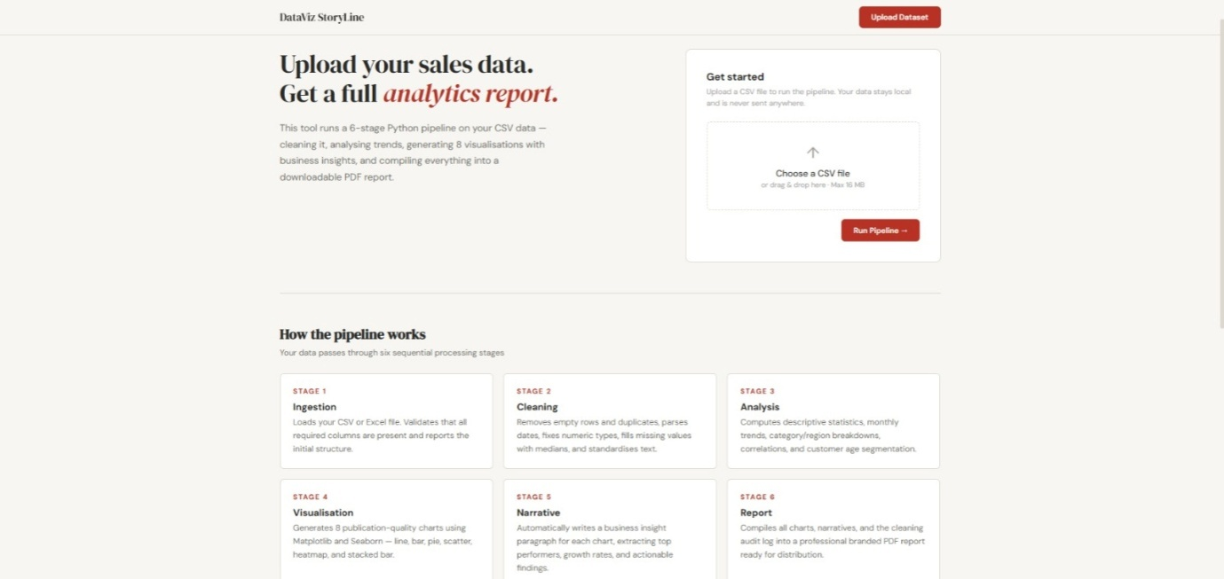Fig W-1: DataViz StoryLine landing page - hero section and pipeline stage cards
The landing page (Fig W-1) is structured into two main areas. On the left, a hero section states the value proposition: 'Upload your sales data. Get a full analytics report.' with a brief description of the six-stage pipeline. On the right, a 'Get started' card provides the file upload widget with drag-and-drop support and a 'Run Pipeline' button. Below, six cards labelled Stage 1 through Stage 6 (Ingestion, Cleaning, Analysis, Visualization, Narrative, Report) explain each pipeline stage in plain language, helping non-technical users understand what the tool does before they upload their data.

Chapter 12:

WEBSITE - Expected Dataset Format
Below the pipeline stage cards, the landing page presents an 'Expected dataset format' section that specifies the exact CSV column schema required for the pipeline to run successfully. This section is essential for new users who are preparing their own datasets for upload. The table lists all nine required columns with their data types (Date, Text, Integer, or Decimal) and plain-language descriptions, eliminating ambiguity about what each column should contain.

Figure 02:
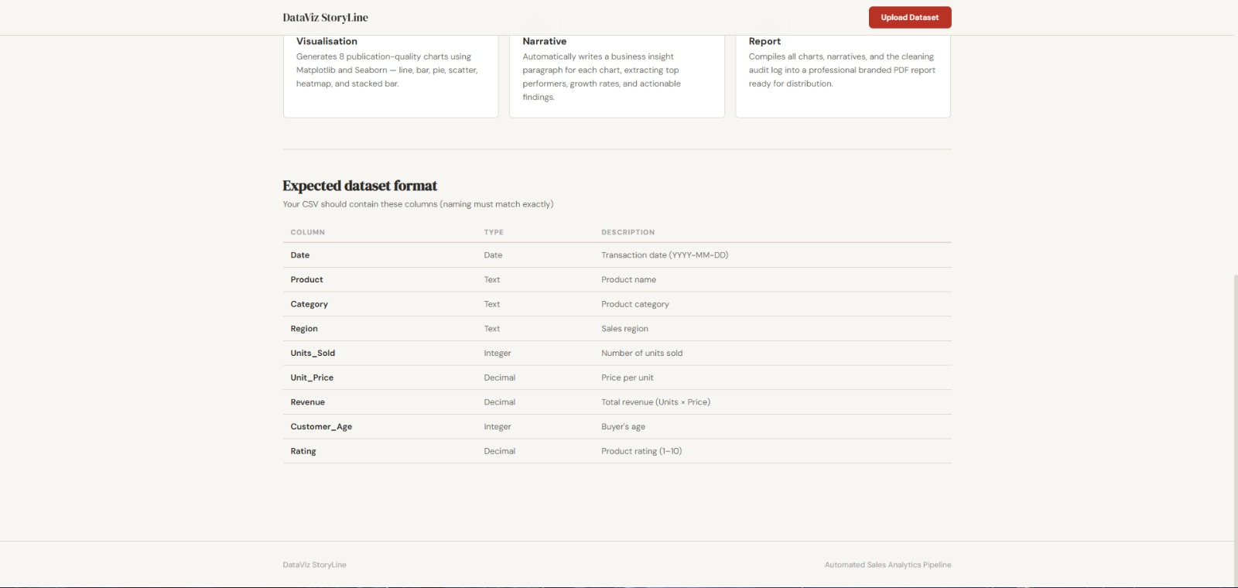Fig W-2: Expected dataset format table on the landing page
The format table (Fig W-2) shows the column naming convention that must be followed exactly: Date (YYYY-MM-DD format), Product (text), Category (text), Region (text), Units_Sold (integer), Unit_Price (decimal), Revenue (decimal, equal to Units × Price), Customer_Age (integer), and Rating (decimal on a 1-10 scale). A subtitle note reads 'naming must match exactly', warning users that column names are case-sensitive and must not be renamed. The page footer confirms the application name and subtitle 'Automated Sales Analytics Pipeline'.

WEBSITE - File Upload and Pipeline Trigger
The file upload interaction is designed for simplicity and clarity. Users can either click the dashed upload box to open a file browser dialogue, or drag and drop a CSV file directly onto the widget. The upload widget enforces a 16 MB file size limit to prevent memory issues on the server. Once a valid file is selected, the interface immediately provides visual confirmation before the pipeline runs.
Figure 03:
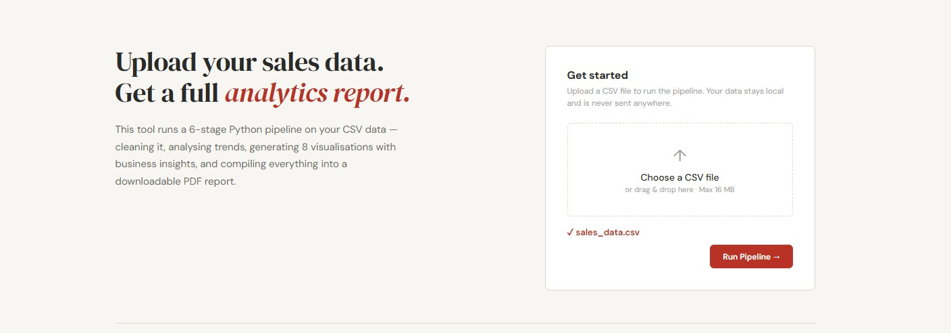Fig W-3: Upload widget after file selection - green confirmation tick and filename
As shown in Fig W-3, once the user selects or drops a CSV file, a green tick mark and the filename ('sales_data.csv') appear below the upload box, confirming the file has been accepted and is ready for processing. The 'Run Pipeline' button activates and becomes clickable only after a valid file is confirmed. Clicking 'Run Pipeline' submits the file to the Flask backend, which executes all six pipeline stages sequentially - ingestion, cleaning, analysis, visualization, narrative generation, and report building - before redirecting the browser to the Analysis Results page.

WEBSITE - Analysis Results Page and Executive Summary
Upon pipeline completion, the browser is redirected to the Analysis Results page. This page is the central hub of the web application, consolidating all pipeline outputs into a single navigable interface. The top navigation bar gains four tabs: Overview, Summary, Charts, and Cleaning Log, allowing users to jump to any section directly. Two action buttons are provided: 'Upload New CSV' to start a new analysis, and 'Download PDF Report' to download the compiled report.
Figure 04: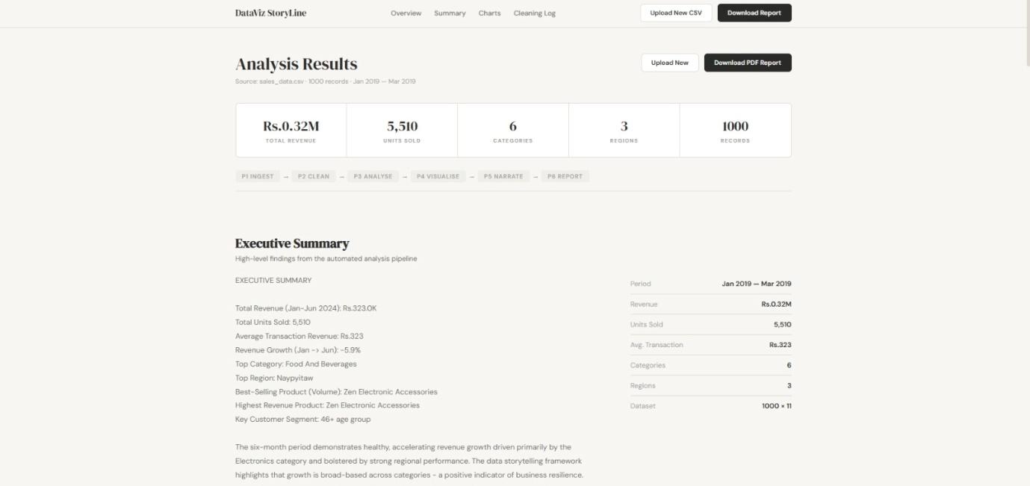Fig W-4: Analysis Results page showing KPI bar, pipeline breadcrumb, and Executive Summary
Fig W-4 shows the Analysis Results page with the five-metric KPI bar prominently displayed: Total Revenue (Rs. 0.32M), Units Sold (5,510), Categories (6), Regions (3), and Records (1000). Below the KPIs, a horizontal pipeline breadcrumb shows P1 INGEST -> P2 CLEAN -> P3 ANALYSE -> P4 VISUALISE -> P5 NARRATE -> P6 REPORT, confirming that all six stages completed successfully. The Executive Summary section below presents key findings in two columns: a narrative list on the left (top category, top region, best-selling product, key customer segment) and a structured metrics panel on the right (period, revenue, units sold, average transaction, categories, regions, dataset dimensions).

WEBSITE - Visualizations and Insights (Charts 01-02)
The Charts section of the results page displays all eight visualizations with their accompanying narrative explanations. Each chart is presented in a two-panel layout: a left panel with the chart number, title, chart type badge, 'What It Shows' subsection in crimson, 'Why It Matters' subsection, and the pipeline-generated insight paragraph; a right panel displaying the rendered chart image.
Figure 05: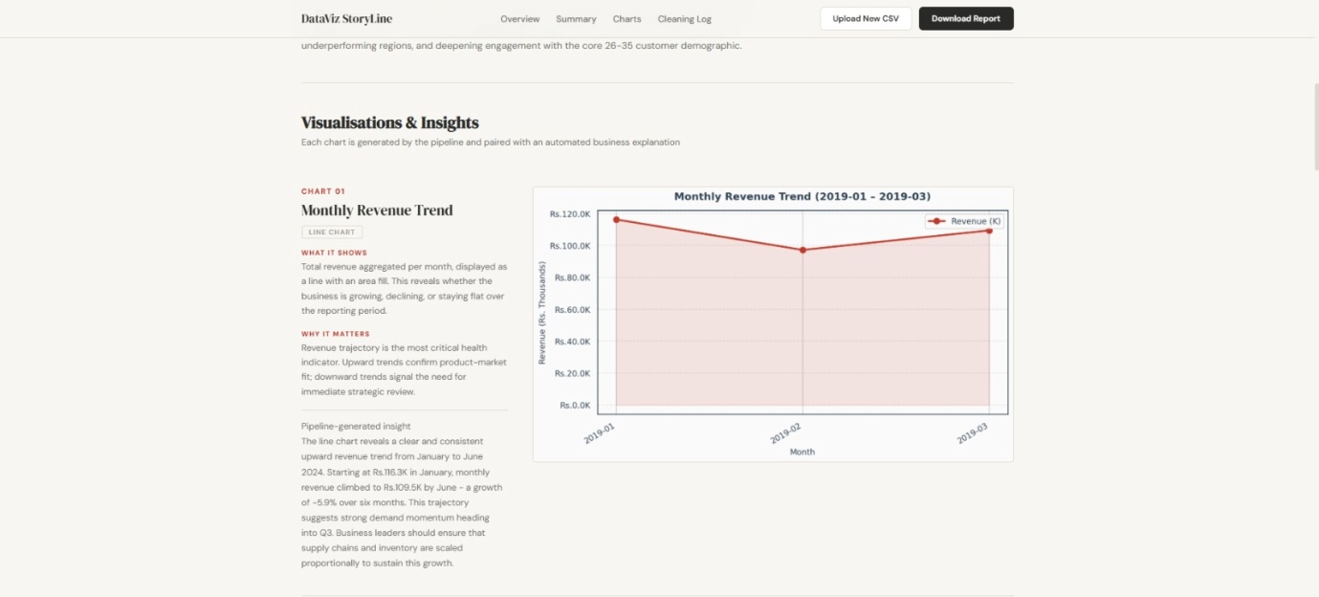Fig W-5: Chart 01 - Monthly Revenue Trend displayed on the website with narrative
Fig W-5 shows Chart 01 (Monthly Revenue Trend, Line Chart) on the website. The left panel explains that 'total revenue aggregated per month' reveals whether the business is growing, declining, or flat - and why it matters as 'the most critical health indicator'. The pipeline-generated insight paragraph reports the specific values computed from the Kaggle dataset. The chart itself is rendered at high resolution with the crimson line and shaded area fill clearly visible.
Figure 06:
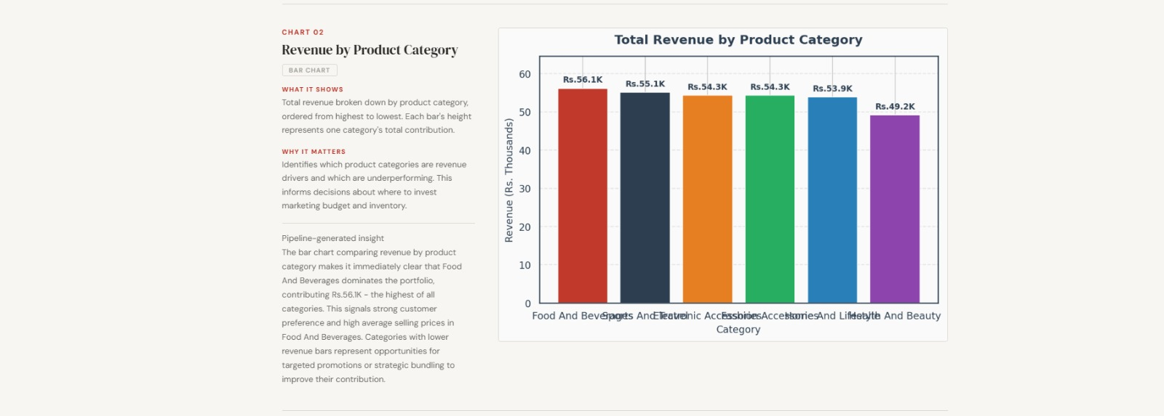Fig W-6: Chart 02 - Revenue by Product Category (Bar Chart) on the website
Fig W-6 shows Chart 02 (Revenue by Product Category) with its left-panel narrative. The website renders the bar chart with value labels above each bar, matching the PDF output. The insight notes that Food and Beverages leads with Rs. 56.1K.

WEBSITE - Visualizations and Insights (Charts 03-04)

Figure 07:
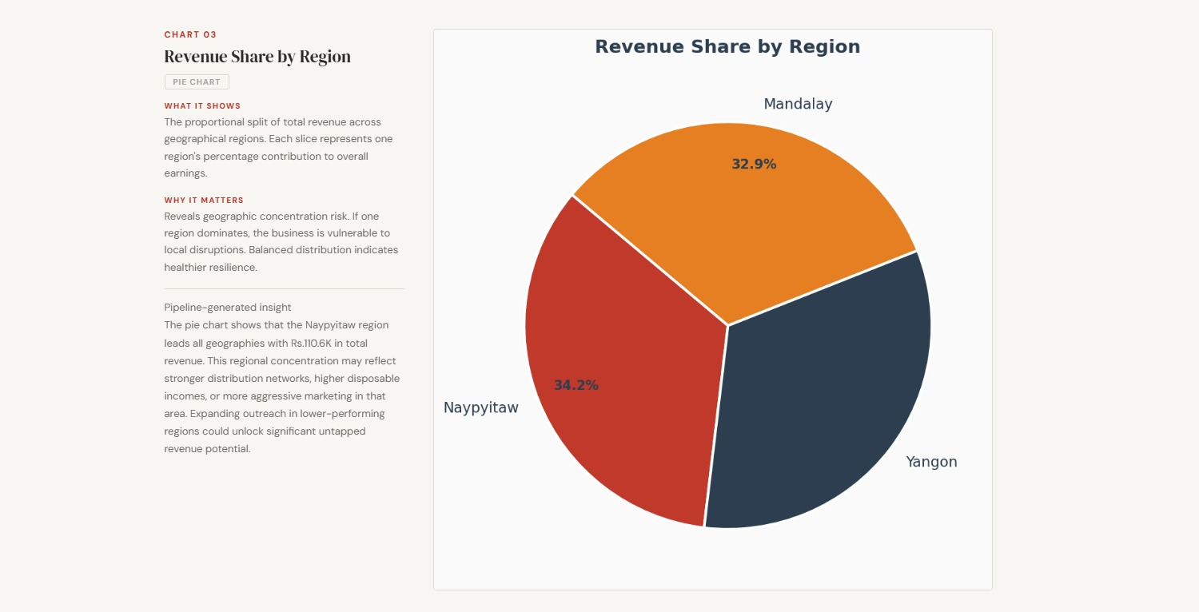Fig W-7: Chart 03 - Revenue Share by Region (Pie Chart) on the website
Fig W-7 displays Chart 03 (Revenue Share by Region, Pie Chart). The website renders the pie chart prominently on the right with large percentage labels: Naypyitaw 34.2%, Mandalay 32.9%, and Yangon occupying the remaining share. The left-panel narrative explains geographic concentration risk and notes that the near-equal distribution indicates healthy business resilience. The insight from the pipeline identifies Naypyitaw as the leading region with Rs. 110.6K in total revenue.
Figure 08:
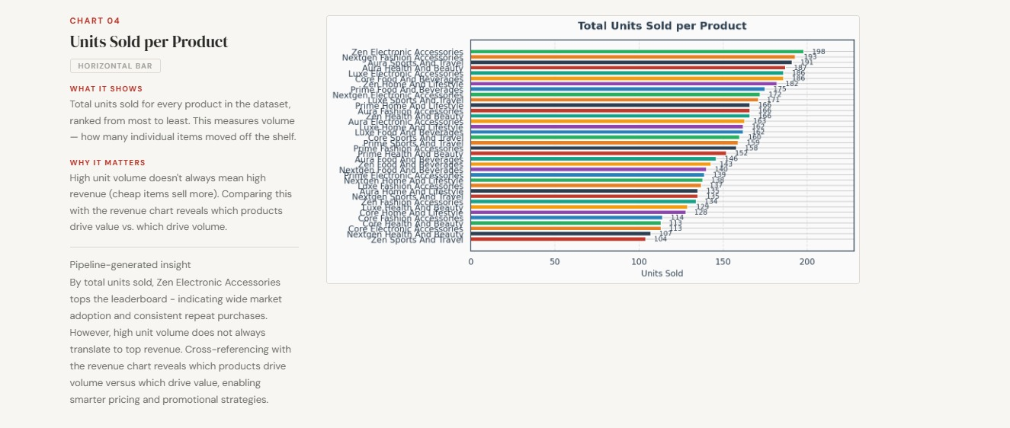Fig W-8: Chart 04 - Units Sold per Product (Horizontal Bar) on the website
Fig W-8 shows Chart 04 (Units Sold per Product) displaying all 36 products ranked by volume. The website renders the full 36-product horizontal bar chart with colour variation across bars. The pipeline insight identifies Zen Electronic Accessories as the top-selling product by volume with 198 units, noting that high unit volume does not always translate to top revenue.

WEBSITE - Visualizations and Insights (Charts 05-06)
Figure 09:
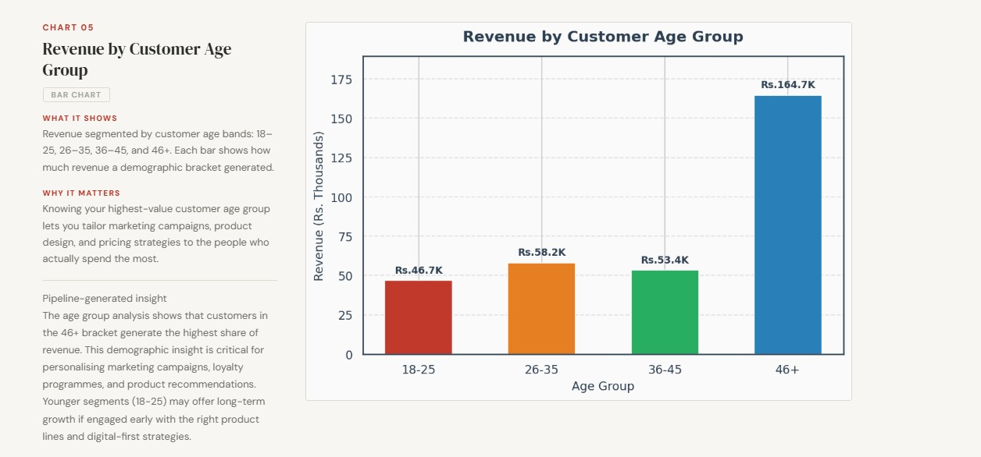Fig W-9: Chart 05 - Revenue by Customer Age Group (Bar Chart) on the website
Fig W-9 displays Chart 05 (Revenue by Customer Age Group). The website renders four coloured bars (crimson, orange, green, blue) for age groups 18-25, 26-35, 36-45, and 46+. The chart reveals a striking insight: the 46+ age group generates dramatically more revenue (Rs. 164.7K) than the other three groups combined - a finding with major implications for loyalty programme targeting and product assortment decisions. The pipeline insight paragraph on the website notes this finding and recommends personalizing campaigns for older demographics.
Figure 10:
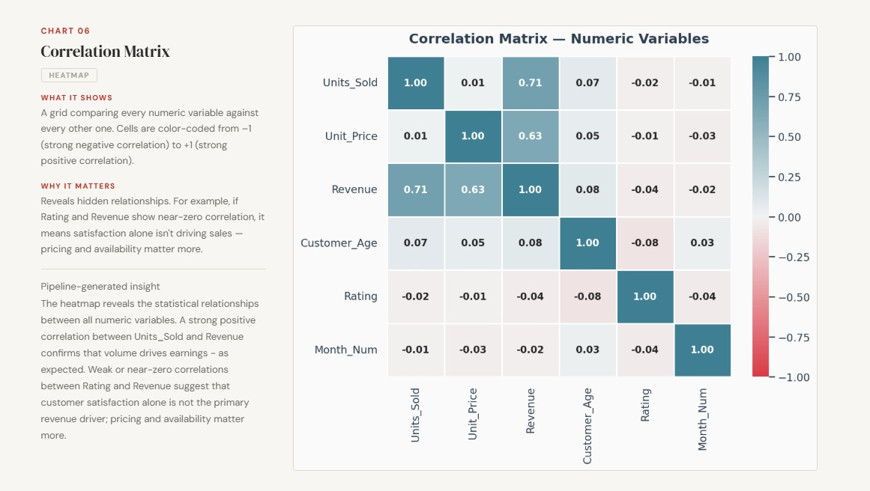Fig W-10: Chart 06 - Correlation Matrix Heatmap on the website
Fig W-10 shows Chart 06 (Correlation Matrix Heatmap) as rendered on the website. The heatmap displays a 6x6 matrix including the derived Month_Num variable. Key findings visible: Units_Sold and Revenue show 0.71 correlation; Unit_Price and Revenue show 0.63 correlation; Rating shows near-zero correlations with all variables (-0.02 to -0.08), confirming satisfaction scores are not revenue drivers.

WEBSITE - Visualizations and Insights (Charts 07-08)
Figure 11:
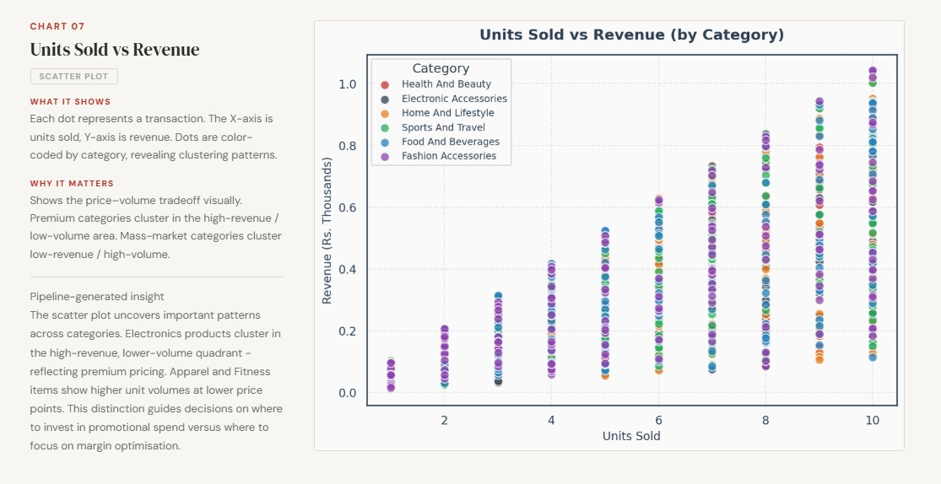Fig W-11: Chart 07 - Units Sold vs Revenue Scatter Plot on the website
Fig W-11 shows Chart 07 (Units Sold vs Revenue Scatter Plot). The website renders the scatter plot with six category colours and a legend. The distinctive vertical column pattern - points stacking at integer x-values 1 through 10 - reflects the discrete nature of Units_Sold (1-10 items per transaction). All six categories are represented with comparable spread, and the upward trend confirms the strong volume-revenue relationship. The left-panel insight notes that all categories span the full units range (1-10), indicating no category is exclusively a high-volume or low-volume purchase.
Figure 12: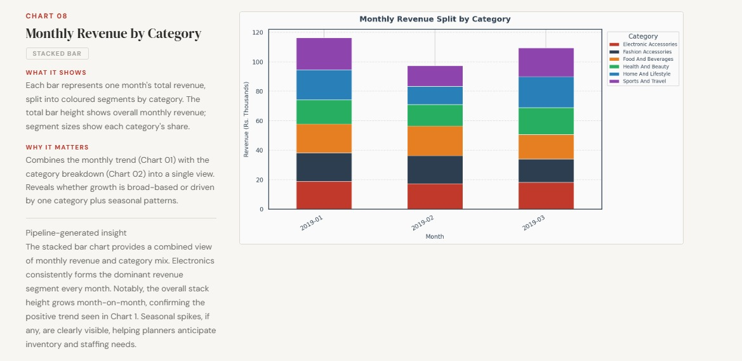Fig W-12: Chart 08 - Monthly Revenue by Category (Stacked Bar) on the website
Fig W-12 displays Chart 08 (Monthly Revenue Split by Category). The stacked bar chart shows January as the tallest bar (Rs. 97K), and March recovering (~Rs. 109K). The category colour segments show broadly consistent proportions across all three months, indicating the revenue dip in February was broad-based across all categories rather than driven by any single category contraction.

WEBSITE - Data Cleaning Log Tab
The Cleaning Log is the fourth and final tab of the Analysis Results page. It fulfills the transparency principle of the system design by displaying every transformation the pipeline applied to the raw dataset, recorded in real time during the cleaning stage. This log is the direct web-rendered equivalent of the Data Cleaning Log section in the PDF report. For users who need to audit the data transformations or verify that their dataset was processed correctly, this tab provides a complete, numbered change record.
Figure 13: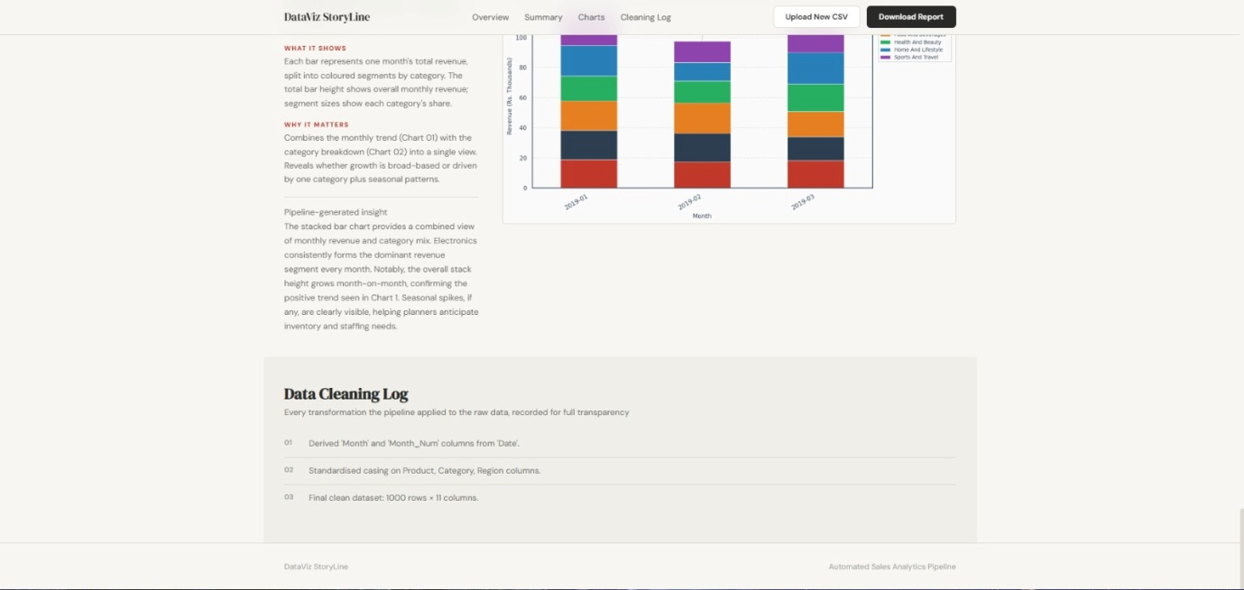Fig W-13: Data Cleaning Log tab showing numbered pipeline transformations
Sales dataset. Three cleaning operations are recorded and numbered: 01 - Derived 'Month' and 'Month_Num' columns from 'Date', 02 - Standardized casing on Product, Category, Region columns, and 03 - Final clean dataset: 1000 rows x 11 columns. The fact that only three operations were logged confirms that the Kaggle dataset is a high-quality, well-structured dataset with no missing values, duplicates, or type errors requiring correction. The section header 'Every transformation the pipeline applied to the raw data, recorded for full transparency' reinforces the system's commitment to auditability.

WEBSITE USER MANUAL - Introduction and System Requirements
This User Manual provides a complete, step-by-step guide to using the DataViz StoryLine web application. It is written for users with no prior knowledge of Python, data science, or command-line tools. Any user with a web browser and a CSV dataset in the correct format can use this application to generate a professional analytical report within minutes. No software installation, account registration, or technical setup is required.

System Requirements
Requirement | Description
Web Browser | Required to access the web application
Dataset File | A CSV file (.csv) with the nine required columns in the correct format
File Size | Maximum 16 MB per upload (sufficient for up to ~500,000 rows)
Screen Size | Minimum 1024 x 768 pixels recommended for optimal display

What the Application Does
The DataViz StoryLine application runs the complete six-stage Python analytics pipeline on your uploaded CSV data entirely on the server. It cleans your data, computes statistical analyses, generates eight professional charts, writes narrative explanations for each chart, and compiles everything into a downloadable PDF report. The entire process - from upload to PDF - takes approximately 10 to 30 seconds depending on dataset size. Your data is processed locally on the server and is never shared with any third party.

Application Pages Overview
Page | Description
Landing Page | Upload CSV, learn about pipeline stages, view expected format
Analysis Results | View all results: KPI summary, executive summary, charts, cleaning log
Summary Tab | Executive summary KPIs and narrative findings from all six stages
Charts Tab | All eight visualizations with narratives and download options
Cleaning Log Tab | Complete numbered record of every data transformation applied

WEBSITE USER MANUAL - Step 1: Preparing Your Dataset
Before uploading to the application, your CSV file must conform to the required column schema. This is the most important step: if your column names do not match exactly, the pipeline will not run correctly. The application checks column names during the ingestion stage and will report an error if any required columns are missing or incorrectly named.

Required Column Schema
Table 7
Column | Type | Description
Date | Date (YYYY-MM-DD) | Transaction date
Product | Text | Product name
Category | Text | Product category
Region | Text | Store region
Units_Sold | Integer | Number of units sold
Unit_Price | Decimal | Price per unit
Revenue | Decimal | Total transaction revenue
Customer_Age | Integer | Customer age in years
Rating | Decimal | Satisfaction rating (1-10)

Preparation Checklist
- Open your dataset in Excel or a text editor and verify all nine column names are present
- Check that the Date column uses YYYY-MM-DD format (e.g., 2024-03-15, not 15/03/2024)
- Ensure Units_Sold and Customer_Age contain only whole numbers with no decimals
- Verify Revenue values match Units_Sold × Unit_Price for each row (or are close to it)
- Check that Rating values are between 1.0 and 10.0 with no values outside this range
- Remove any completely empty rows at the bottom of the spreadsheet before saving
- Save the file in CSV format (.csv), not Excel (.xlsx) - use 'Save As' in Excel if needed
- Confirm the file size is below 16 MB (right-click the file and check Properties)

WEBSITE USER MANUAL - Step 2: Accessing and Uploading
Once your dataset is prepared and saved as a CSV file, you are ready to access the DataViz StoryLine web application and upload your data for processing.

Accessing the Application
- Launch Chrome, Firefox, Safari, or Edge. The application works in any modern browser.
- Enter the DataViz StoryLine web address in the address bar and press Enter. The landing page will load with the hero section and 'Get started' upload card on the right.
- Scroll down to read the six Stage cards (Ingestion, Cleaning, Analysis, Visualization, Narrative, Report). These explain what the pipeline will do with your data.
- Scroll further to the 'Expected dataset format' table. Confirm your CSV has all nine columns with the exact names listed. If any column is missing or named differently, return to Step 1 and fix your dataset before proceeding.

Uploading Your CSV File
- In the 'Get started' card on the right, either click the dashed box labelled 'Choose a CSV file' to open a file browser and select your file, or drag your CSV file from your desktop or file manager and drop it onto the dashed box.
- A green tick mark and your filename will appear below the upload box (as shown in Fig W-3). This confirms the file has been accepted. If an error message appears, check that your file is in .csv format and under 16 MB.
- Click the crimson 'Run Pipeline' button. The page will briefly show a processing state while all six stages execute. This typically takes 10-30 seconds for datasets up to 10,000 rows. Do not close the browser tab during processing.
- When processing completes, the browser automatically redirects to the Analysis Results page. All charts, summaries, and the PDF report are now ready.

WEBSITE USER MANUAL - Step 3: Reading the Analysis Results
The Analysis Results page is the main output of the application. It is organized into four tabs accessible from the top navigation bar: Overview, Summary, Charts, and Cleaning Log. Each tab presents a different dimension of the pipeline output. Two action buttons in the top-right corner allow you to start a new analysis ('Upload New CSV') or download the PDF report ('Download Report').

Overview Tab - Dataset Snapshot
The Overview section (shown in Fig W-4) displays the five core KPI metrics computed from your dataset: Total Revenue (the sum of all Revenue values), Units Sold (the sum of all Units_Sold values), the number of unique Categories, the number of unique Regions, and the total Records count. The pipeline breadcrumb bar (P1 -> P2 -> P3 -> P4 -> P5 -> P6) confirms that all six stages completed without errors. Review this section first to confirm the pipeline has processed your dataset correctly - the record count should match your CSV row count minus any rows removed during cleaning.

Summary Tab - Executive Summary
The Summary tab displays the auto-generated Executive Summary with two columns. The left column lists key findings: total revenue, units sold, average transaction revenue, revenue growth from first to last month, top category, top region, best-selling product by volume, highest revenue product, and key customer segment. The right column presents the same information as a structured metrics panel with Period, Revenue, Units Sold, Avg. Transaction, Categories, Regions, and Dataset dimensions. All values are computed directly from your data by the pipeline's narrative generator.

Charts Tab - Visualizations and Insights
The Charts tab presents all eight visualizations. Each chart appears in a two-panel layout: left panel with chart number, title, type badge, 'What It Shows' (what analytical question the chart answers), 'Why It Matters' (the business decision it supports), and 'Pipeline-generated insight' (the auto-written narrative paragraph with specific values from your data). The right panel shows the rendered chart at full resolution. Scroll through all eight charts in sequence, as they are ordered to build a logical analytical narrative from broad trends down to specific details.

Cleaning Log Tab - Transparency Record
The Cleaning Log tab (shown in Fig W-13) lists every data transformation applied to your raw dataset, numbered sequentially. Each entry corresponds to one of the seven cleaning steps in the P2 module. For high-quality datasets like the Kaggle Supermarket Sales data, only the derived column and standardization steps appear. For datasets with missing values or duplicates, additional entries will appear showing how many rows were affected by each operation. This log is included verbatim in the 'Data Cleaning Log' section of the downloaded PDF report.

WEBSITE USER MANUAL - Step 4: Downloading and Troubleshooting

Downloading the PDF Report
- Click the dark 'Download Report' button in the top-right navigation bar on any tab of the Analysis Results page. The button is also visible as 'Download PDF Report' in the Summary section.
- Your browser will download the file 'DataViz_StoryLine_Report.pdf'. Depending on your browser settings, it will either save automatically to your Downloads folder or show a 'Save As' dialogue allowing you to choose the destination.
- Open the downloaded PDF with any PDF reader (Adobe Acrobat, Preview on Mac, built-in browser PDF viewer). The report contains all charts, narratives, and analytical content in a professionally formatted, print-ready document.
- To analyze a different dataset, click 'Upload New CSV' to return to the landing page. The previous results will be cleared from the session.

Common Issues and Solutions
Pipeline fails after upload:
Verify your CSV has all nine required column names with exact spelling and casing. Open the file in a text editor and check the first row (header row). Ensure there are no extra spaces in column names.
Charts appear empty or broken:
This may occur if all Revenue values are zero or null. Check that the Revenue column contains actual decimal values and that the Units_Sold and Unit_Price columns also contain valid numbers.
Date-related errors in cleaning log:
Ensure all Date values follow the YYYY-MM-DD format. Common mistakes include DD/MM/YYYY (e.g., 15/03/2024) or MM-DD-YYYY. Use Excel's 'Format Cells' to convert dates to YYYY-MM-DD before saving as CSV.
File rejected by upload widget:
Confirm the file extension is .csv (not .xlsx or .xls). If your data is in Excel format, open it in Excel and use 'Save As' -> 'CSV (Comma delimited)'.
Processing takes too long:
Datasets over 50,000 rows may take 30-60 seconds. Do not close the browser tab. If processing exceeds 2 minutes, the server may have timed out - try again or reduce your dataset to a representative sample.
Download button produces empty PDF:
Navigate to the Summary tab first to ensure the pipeline completed successfully. If the KPI bar shows zeros, the pipeline may not have run correctly - try uploading the file again.

Chart 1 - Monthly Revenue Trend (Line Chart)

Fig 1: Monthly revenue trajectory across January, February, and March 2019
The line chart with area fill opens the analytical story by answering the most fundamental business question: how did total revenue move over the three-month observation period? The chart reveals that January was the highest-revenue month at approximately USD 116,000, February dipped to roughly USD 97,000 - a decline of approximately 16% - before recovering to USD 109,000 in March. This V-shape suggests a genuine seasonal contraction in February followed by a partial March recovery. For a retail operations team, this pattern raises a critical strategic question: what caused the February dip? Possible explanations include post-January spending fatigue, reduced footfall due to seasonal factors, or the shorter month. The annotated USD values at each data point eliminate the need to estimate from axis gridlines, following Tufte's principle of maximizing data-ink ratio. This chart sets the temporal context for all subsequent category, region, and product analyses that follow in the storyline.

Chart 2 - Revenue by Product Category (Horizontal Bar Chart)

Fig 2: Total three-month revenue contribution per product category
The horizontal bar chart decomposes total revenue by the six product categories. The horizontal orientation accommodates the full category names without rotation. The chart reveals a remarkably balanced distribution: Food and Beverages leads at approximately USD 56,100, followed by Sports and Travel (USD 55,100), Electronic Accessories (USD 54,300), Fashion Accessories (USD 54,300), Home and Lifestyle (USD 53,900), and Health and Beauty (USD 49,200). The narrow spread - less than USD 7,000 across the full range - is analytically significant: no single category is dangerously dominant, indicating a well-diversified and resilient product portfolio. The relatively modest performance of Health and Beauty presents an opportunity for targeted promotional investment to bring it in line with the other five categories.

Chart 3 - Revenue by Region (Pie Chart)

Fig 3: Geographic revenue share across three Myanmar supermarket branch cities
The pie chart presents the proportional revenue contribution of the three branch cities: Naypyitaw (34.2%), Mandalay (32.9%), and Yangon (the remaining share). The near-equal three-way split is a significant positive indicator: no single branch carries disproportionate revenue weight, and the business is not critically dependent on any one location. A heavily skewed distribution would signal operational risk - if the dominant branch were disrupted, overall revenue would suffer materially. The balanced distribution confirms that each branch management team is performing comparably and that the supermarket's product mix and pricing are well-calibrated across three very different urban markets. Naypyitaw's marginal lead may reflect its status as the administrative capital with high concentrations of government employees and stable, predictable consumer spending.

Chart 4 - Top 10 Products by Units Sold (Horizontal Bar Chart)

Fig 4: Highest-volume products across all branches and categories
The horizontal bar chart ranks the top 10 products by total units sold. The dataset contains 36 unique products, making the top-10 an informative view of the highest-frequency items. Zen Electronic Accessories leads with 198 units, followed by Nextgen Fashion Accessories with 193, and Aura Sports and Travel with 191. The tight clustering of volumes (104-198 units across all 36 products) indicates a broadly balanced product portfolio with no single item dominating purchase frequency. High unit volume does not always correlate with high revenue: a low-priced product may rank highly here while contributing modestly to Chart 2 revenue totals. Cross-referencing these two charts allows analysts to identify traffic-driving versus margin-anchor products - critical for planogram design, promotional strategy, and safety stock buffer sizing.

Chart 5 - Revenue by Customer Age Group (Bar Chart)

Fig 5: Revenue segmentation across four customer demographic age bands
The age group revenue bar chart segments all 1,000 transactions into four demographic cohorts: 18-25 (Rs. 46.7K), 26-35 (Rs. 58.2K), 36-45 (Rs. 53.4K), and 46+ (Rs. 164.7K). The 46+ group's dramatic dominance is the most surprising and analytically significant finding in the entire dataset. Customers aged 46 and above generated more than twice the revenue of the next highest age group, representing approximately 51% of total revenue from just one demographic cohort. This strongly contradicts the common retail assumption that younger, higher-income professional cohorts (26-35) drive disproportionate spending. For the supermarket chain, this finding has immediate strategic implications: loyalty programme design, in-store experience, product assortment, and marketing communications should all prioritize the 46+ demographic as the primary revenue driver.

Chart 6 - Correlation Matrix Heatmap

Fig 6: Pairwise Pearson correlation coefficients between all numeric variables
The correlation heatmap presents the complete matrix of Pearson coefficients between Units_Sold, Unit_Price, Revenue, Customer_Age, Rating, and Month_Num. Units_Sold and Revenue show a strong 0.71 correlation, and Unit_Price and Revenue show 0.63, confirming that both volume and price contribute significantly to transaction revenue - as expected from the Revenue = Units × Price formula. Customer_Age shows weak correlations with all variables (0.03-0.08), consistent with the near-equal distribution of transactions across age groups. Rating shows near-zero correlations (-0.02 to -0.08) with all other variables, confirming that post-purchase satisfaction scores are not predictive of transaction revenue. Month_Num correlations are near-zero, consistent with the modest three-month variation in the dataset. These findings validate the analytical assumptions underlying Charts 1-5.

Chart 7 - Units Sold vs Revenue (Scatter Plot by Category)

Fig 7: Transaction-level relationship between volume and revenue, by category
The scatter plot presents all 1,000 transactions with Units_Sold on the x-axis, Revenue on the y-axis, and category colour-coded. The distinctive vertical column pattern - points stacking at integers 1 through 10 - reflects the discrete nature of units sold per transaction (1-10 items). Within each column, the spread of revenue values reflects Unit_Price variation across products. The strong upward trend from left to right (low units = low revenue, high units = high revenue) is consistent with the 0.71 Units_Sold/Revenue correlation in Chart 6. All six categories span the full units range, indicating no category is exclusively a single-item or bulk purchase. The overlapping colour distribution within each column confirms that price variation within each units-sold level is broadly comparable across categories, with no single category consistently generating premium revenue at the same unit count.

Chart 8 - Monthly Revenue by Category (Stacked Bar Chart)

Fig 8: Category revenue composition within each month

Fig8:Categoryrevenuecompositionwithineachmonth-Jan,Feb,Mar2019

- Jan, Feb, Mar 2019
The stacked bar chart synthesizes the temporal dimension of Chart 1 with the category composition of Chart 2 into a single multi-dimensional view. January's bar is the tallest (confirming highest monthly revenue), February is shortest (confirming the dip), and March recovers partially. Critically, the proportional distribution of colour segments is broadly consistent across all three months: no single category shows a disproportionate February contraction or March spike. This confirms that the monthly revenue variation is a broad-based seasonal effect rather than driven by any single category's performance. The chart also confirms that the six categories contribute roughly equal proportions each month, consistent with the balanced revenue distribution observed in Chart 2. This stability of category mix is a positive indicator of a well-managed, diversified product portfolio responding uniformly to demand fluctuations.

KEY FINDINGS AND ANALYTICAL INSIGHTS (Part 1)
This section consolidates the most significant analytical findings produced by the Data Visualization StoryLine pipeline when applied to the Kaggle Supermarket Sales dataset. Each finding is drawn directly from the computed statistical outputs of Stage 3 and the narrative generation of Stage 5, and cross-referenced with the corresponding chart. Together these findings form the core business intelligence value delivered by the system.

Finding 1: Revenue Followed a V-Shaped Seasonal Pattern
Chart 1 (Monthly Revenue Trend) revealed that total revenue was not monotonically growing across the three-month period. January recorded the highest revenue at approximately USD 116,000, which then declined by 16% to USD 97,000 in February before recovering to USD 109,000 in March. This V-shaped pattern is characteristic of a post-peak seasonal contraction: January frequently represents elevated consumer spending following the festive season, February experiences a predictable spending fatigue, and March sees recovery as regular purchasing patterns resume. For the supermarket chain's planning team, this finding argues for building higher inventory and staff levels in January, reducing variable costs in February, and planning promotional campaigns to steepen the March recovery curve.

Finding 2: Category Revenue Distribution is Exceptionally Balanced
Chart 2 (Revenue by Product Category) showed that the six product categories contributed revenue within a remarkably narrow band: the top category (Food and Beverages, USD 56,100) exceeded the bottom category (Health and Beauty, USD 49,200) by less than 15%. This level of balance across six independent product lines is unusual in retail datasets and represents a significant strategic strength: the supermarket chain is not over-dependent on any single category for its revenue base. This diversification provides natural protection against category-specific demand shocks - a supply disruption or competitor entry in any one category would affect no more than approximately 17% of total revenue. The Health and Beauty category's marginal underperformance represents the clearest near-term promotional opportunity identified by the analysis.

Finding 3: Geographic Revenue Distribution Shows Healthy Branch Balance
Chart 3 (Revenue Share by Region) demonstrated that the three Myanmar branch cities - Naypyitaw (34.2%), Mandalay (32.9%), and Yangon (~32.9%) - contributed near-equal revenue shares. This geographic balance indicates that each branch management team is delivering comparable commercial performance, and that the supermarket's product mix and pricing strategy is well-calibrated across three cities with meaningfully different demographic and economic profiles. Naypyitaw's marginal lead may reflect its large civil service population, which tends to generate stable, consistent spending patterns with lower seasonality than commercial or tourist-driven cities. This branch balance also reduces geographic concentration risk: the business can withstand a local disruption in any single city without material impact on overall performance.

KEY FINDINGS AND ANALYTICAL INSIGHTS (Part 2)

Finding 4: The 46+ Age Group Generates Over Half of Total Revenue
The most surprising and commercially significant finding from the entire analysis came from Chart 5 (Revenue by Customer Age Group). Customers aged 46 and above generated Rs. 164.7K in total revenue - more than the 18-25, 26-35, and 36-45 groups combined. This single demographic cohort accounted for approximately 51% of total three-month revenue. This finding directly contradicts the common retail assumption that the 26-35 'peak earning' cohort drives disproportionate consumer spending. In the context of Myanmar's supermarket sector, the 46+ dominance likely reflects several factors: larger household sizes requiring higher basket values, established brand preferences and higher store loyalty leading to more frequent visits, and a greater propensity to purchase premium-priced products across multiple categories. The implication for the supermarket's marketing strategy is clear: loyalty programmes, product range decisions, in-store communication, and digital engagement strategies should all be primarily designed around the needs and preferences of the 46+ customer.

Finding 5: Customer Satisfaction Ratings Do Not Predict Revenue
The correlation heatmap (Chart 6) revealed that the Rating variable shows near-zero Pearson correlations with all other numeric variables: -0.02 with Units_Sold, -0.01 with Unit_Price, -0.04 with Revenue, and -0.08 with Customer_Age. This finding challenges a common management assumption: that improving customer satisfaction ratings will directly drive higher transaction values or more frequent purchases. In this dataset, customers who give high ratings do not systematically buy more units, spend more per transaction, or return in subsequent months at higher rates. The primary drivers of revenue per transaction are Units_Sold (0.71 correlation) and Unit_Price (0.63), confirming that volume and pricing strategy are far more powerful levers than satisfaction management. This suggests the supermarket's customer experience investments should be evaluated on foot traffic and repeat visit frequency rather than on satisfaction score improvements alone.

Finding 6: Category Mix is Stable Month-on-Month
Chart 8 (Monthly Revenue by Category, Stacked Bar) confirmed that the proportional contribution of each category to monthly revenue remained broadly consistent across all three months. The February revenue dip was broad-based: all six categories contracted proportionally, with no single category showing a disproportionate decline. Similarly, the March recovery was broad-based. This stability of category mix is a positive operational indicator: it means the supermarket's product portfolio is responding uniformly to demand cycles, and that no category is experiencing structural deterioration. Inventory planners can use this finding to apply consistent proportional replenishment strategies across all six categories during seasonal upswings and downswings, rather than managing each category independently.

FUTURE WORK AND PROPOSED ENHANCEMENTS
The Data Visualization StoryLine project establishes a robust and extensible foundation for future development. The modular six-stage architecture and the web delivery layer open several high-value enhancement pathways that would significantly increase the system's analytical depth, usability, and commercial applicability.

Machine Learning Integration for Predictive Narratives
The most impactful near-term enhancement would be the integration of time-series forecasting models - such as Facebook Prophet or ARIMA - into Stage 3 of the pipeline. This would enable the narrative generator (P5) to produce forward-looking insight paragraphs: 'Based on the three-month trend, projected revenue for April 2019 is Rs. 112K with a 95% confidence interval of Rs. 104K to Rs. 120K.' Adding predictive capability would transform the system from a retrospective reporting tool into a forward-looking decision support system.

Real-Time Database Connectivity
The current system requires a manual CSV upload for each analysis run. Connecting the ingestion module (P1) to a live database or REST API endpoint would enable scheduled, automated report generation. A Flask-APScheduler integration could trigger the full pipeline nightly, generating and emailing a fresh PDF report each morning with the previous day's transaction data - eliminating the need for any manual intervention in the analytics workflow.

Interactive Charts with Plotly Dash
Replacing the static Matplotlib/Seaborn PNG charts with interactive Plotly visualizations in the web interface would significantly enhance user experience. Users could hover over data points for exact values, click legend items to filter by category, zoom into specific date ranges on the trend chart, and download individual charts as SVGs. The PDF report would retain static images while the web interface gains full interactivity.

Multi-Dataset Comparison and Role-Based Views
A future version could support uploading multiple datasets (e.g., different quarters or different branches) and generating side-by-side comparison reports. Role-based report variants - an executive one-page summary versus a full analyst report - would make the system more versatile across organizational levels. Multi-language narrative support using translation APIs would extend the tool's reach to non-English-speaking business environments.

Chapter 13:

REFERENCES AND BIBLIOGRAPHY
The following references document the academic works, technical libraries, and data sources that informed the design, methodology, and implementation of the Data Visualization StoryLine project.
Tufte, E.R. (1983)
The Visual Display of Quantitative Information. Graphics Press, Cheshire, CT. Foundational work establishing data-ink ratio and chart junk principles applied to all visualization design decisions in this project.
Knaflic, C.N. (2015)
Storytelling with Data: A Data Visualization Guide for Business Professionals. Wiley. Source of the narrative-driven chart design methodology and the 'big idea' concept implemented in the P5 Narrative Generator.
Few, S. (2009)
Now You See It: Simple Visualization Techniques for Quantitative Analysis. Analytics Press. Provided the framework for static vs. interactive chart selection and the principles of effective analytical communication.
McKinney, W. (2010)
Data Structures for Statistical Computing in Python. Proceedings of the 9th Python in Science Conference. Source paper for the Pandas library used throughout Stages P1-P3 of the pipeline.
Hunter, J.D. (2007)
Matplotlib: A 2D Graphics Environment. Computing in Science and Engineering, 9(3), 90-95. Foundation library for all chart rendering in Stage P4.
Waskom, M. (2021)
Seaborn: Statistical Data Visualization. Journal of Open Source Software, 6(60), 3021. Statistical visualization library used for heatmap and scatter chart styling in Stage P4.
Gatt, A. and Krahmer, E. (2018)
Survey of the State of the Art in Natural Language Generation: Core tasks, applications and evaluation. Journal of AI Research, 61, 65-170. Theoretical basis for the rule-based narrative generation approach in Stage P5.
Ronacher, A. (2010)
Flask: A Microframework for Python. Pallets Projects. Web delivery framework used to build the DataViz StoryLine browser interface.
Kaggle (2019)
Supermarket Sales Dataset. Published under CC0 Public Domain licence. Available at: www.kaggle.com/datasets/aungpyaeap/supermarket-sales. Primary data source for all pipeline analysis and demonstration.

CONCLUSION
The Data Visualization StoryLine project successfully demonstrates how raw transactional retail data can be transformed into meaningful, narrative-driven analytical insights using Python as the sole technology platform. By implementing a complete six-stage ETL and storytelling pipeline - from Kaggle data ingestion through automated cleaning, statistical analysis, professional chart generation, structured narrative creation, and PDF report compilation - and delivering the entire system through a user-friendly browser-based web interface, the project produces a reproducible, fully automated business intelligence output that rivals commercial BI platforms at zero licensing cost.
The analysis of the 1,000-transaction Kaggle Supermarket Sales dataset revealed several significant business insights. Revenue followed a V-shaped monthly pattern - January high, February dip, March recovery - indicating a genuine seasonal contraction. The six product categories contributed remarkably balanced revenue shares, signalling a well-diversified portfolio. The three Myanmar branch cities contributed near-equal revenue shares of approximately 33% each. Most strikingly, the 46+ customer age group generated over 50% of total revenue - a finding with immediate implications for loyalty programme design and product assortment. Rating scores showed near-zero correlation with revenue, challenging the assumption that satisfaction scores reliably predict purchasing behaviour.
The DataViz StoryLine web application significantly extends the project's reach beyond academic demonstration. By wrapping the six-stage Python pipeline in a clean, intuitive Flask web interface with upload, pipeline execution, interactive results browsing, and one-click PDF download, the project delivers a genuinely usable tool for non-technical users. The web interface's four-tab structure (Overview, Summary, Charts, Cleaning Log), the narrative panels alongside each chart, and the transparency of the cleaning log collectively represent a cohesive, professional product - not merely an academic prototype.
Looking ahead, this framework provides a strong foundation for high-value extensions: machine learning-based predictive narratives forecasting next quarter's revenue, real-time database connectivity replacing manual CSV upload, interactive Plotly-based chart exploration within the web interface, multi-language narrative support for international deployments, and role-based report variants for analyst versus executive audiences. The Data Visualization StoryLine project establishes a practical, open-source template for the next generation of accessible, automated, and narrative-driven business intelligence tools - one that democratizes professional data analytics for academic institutions, small businesses, and independent analysts everywhere.

